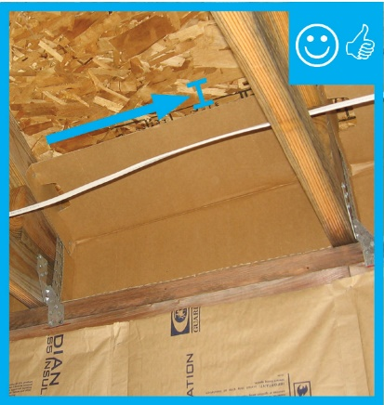 | WHAT?  In vented attics, insulation is installed over taped and mudded drywall, which serves as the continuous air barrier. To help maintain consistent insulation over this ceiling air barrier, wind dams and baffles should be installed in the attic in every rafter bay that has a soffit vent. Wind dams consist of rigid material that is installed at the vertical edge of the insulation nearest the eaves.
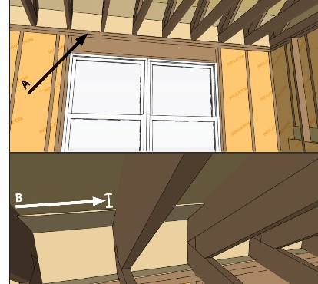 | WHY?  Ventilation helps cool attics and also remove excess moisture, but it can also interfere with insulation. For insulation to perform, it must be installed at the correct depth throughout the attic, including the eaves. Wind dams help keep insulation in place and ensure air coming in from the soffit vents doesn’t blow it out of place.
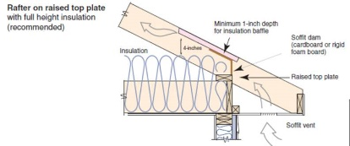 | HOW?  A wind dam (also called a soffit dam) consists of a piece of rigid material (rigid foam, OSB, or plywood) that is installed vertically just outside of the top plate. The dam directs ventilation air up to the underside of the roof; it also prevents wind that enters the soffit vent from pushing insulation away from the eaves and prevents insulation from falling out of place.
INSULATION PROCESS/REQUIREMENTS: CEILINGS: WIND DAMS

