WHAT?
For a home to earn the WaterSense® label:
- Install WaterSense-certified bathroom sink faucets and accessories, which can reduce a sink’s water use by 30 percent without sacrificing performance.
- Install kitchen sink faucets testing at a maximum of 2.2 gallons per minute (gpm).
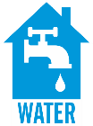
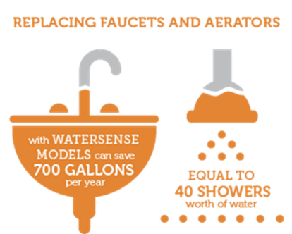 | WHY?  Replacing faucets and faucet accessories WaterSense-certified models can save 700 gallons per year, which is equal to 40 showers’ worth of water.
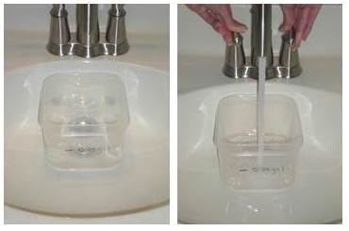 | HOW?  For a new home to earn the WaterSense® label, all bathroom and kitchen sink faucets or faucet accessories must be WaterSense-certified. A faucet accessory is a device that can be added to or removed from a sink faucet (typically, it screws onto the tip of the faucet spout). These usually serve as the flow control mechanism that determines if a faucet meets the minimum and maximum flow rate requirements of the WaterSense specification.  - All bathroom faucets must have a flow rate that does not exceed 1.5 gpm (5.7 liters per minute [lpm]) at a pressure of 60 psi (414 kPa) at the inlet when water is flowing; a flow test does not exceed 0.25gal. Also, the flow rate should be no less than 0.8 gpm (3.0 lpm) at a pressure of 20 psi (138 kPa) at the inlet when water is flowing.  - All kitchen sink faucets should comply with federal standards for a maximum flow rate of 2.2 gpm (8.3 lpm); a flow test does not exceed 0.4 gal.
WATER VOLUME NEEDS BASED ON ROOM: BATHROOM AND KITCHEN FAUCETS

