WATER-RESISTANT MATERIAL (WATER-MANAGED FOUNDATION)
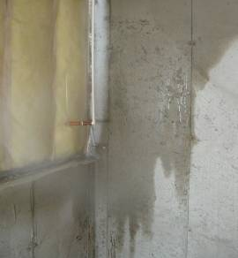 | WHAT?  Water threats can come in the form of rain/stormwater runoff, groundwater intrusion, movement of moist air, water vapor movement, or bulk water leaks from inside the basement (e.g., plumbing leaks).
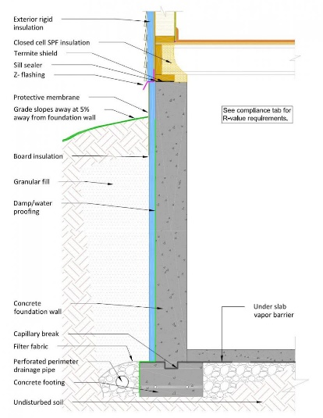 | WHY?  Water management is critical in addressing overall foundation durability and creating healthy basement conditions. Mold and insect/pest issues, decreased IAQ, etc. can result from water damage. Using water-resistant materials around the foundation and basement is part of a comprehensive set of measures that minimize the risk of water damage to these areas.
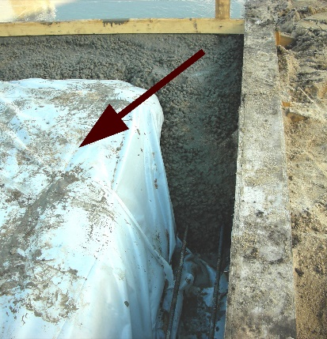 | HOW?  Insulating basement walls without properly addressing moisture management can mask future problems, so before installing insulation, use a vapor barrier under slabs and on crawlspace floors, and damp-proof the exterior of foundation walls. Before insulating the basement, be sure to evaluate these additional critical matters:  - Combustion and appliance safety  - Radon and carbon monoxide safety  - Insect/pest considerations

