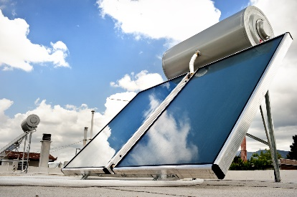 | WHAT?  Solar water heaters (sometimes called solar domestic hot water systems) are a cost-effective way to generate hot water for a home. Though they come with an upfront investment, that money comes back in the form of free energy.
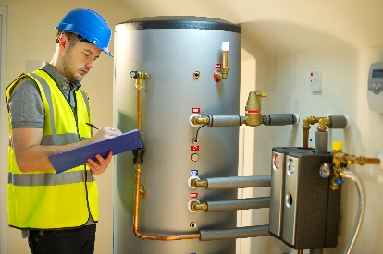 | WHY?  Solar water heaters can be used in any climate, they save money in the long run, and the fuel they use—sunshine—is free. Maintenance on simple systems, preferably by a solar contractor, can be as infrequent as every 3-5 years. The standard home will see an average of at least a 50% reduction in water-heating electricity use, and this number can be much higher in places that get a lot of sun, such as the American southwest.
HOW?
Solar water heating systems use both direct and diffuse solar radiation; conventional storage water heaters often provide backup and may already be part of the solar system package. Solar hot water collectors should be situated to maximize the amount of daily and seasonal solar energy that they receive; generally, the optimum orientation for a solar collector in the northern hemisphere is true south.

WATER HEATERS USE VARIOUS MEANS FOR FUEL: SOLAR WATER HEATERS

