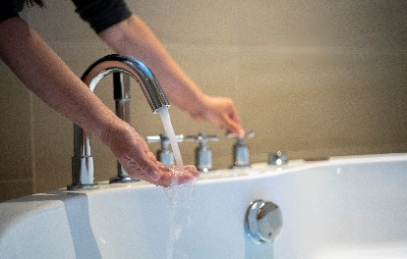 | WHAT?  Another way to reduce the amount of energy needed for water heating is a high-efficiency heat pump water heater.  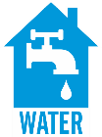
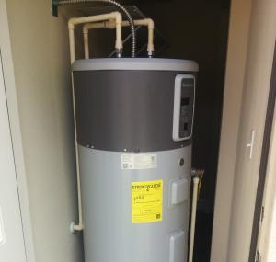 | WHY?  High-efficiency heat pump water heaters minimize wasted energy producing hot water, which translates to plentiful hot water at lower cost. Although they use electricity, these water heaters can be two to three times more efficient than conventional electric-resistance water heaters.
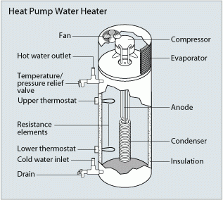 | HOW?  This water heater operates on the same principle as the whole-house air source heat pumps, which move heat with electric compressors and pumps, but instead of heating and cooling homes, they move heat from the surrounding space into the water tank. A standalone heat pump water heating system can be purchased as an integrated unit, with a built-in water storage tank and backup resistance heating elements. This type of water heater can also be retrofitted to work with an existing conventional storage water heater.
WATER HEATERS USE VARIOUS MEANS FOR FUEL: HEAT PUMP WATER HEATERS

