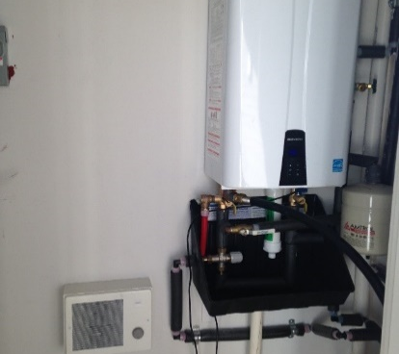 | WHAT?  Another way to significantly reduce water heating energy is through installation of a tankless water heater. It provides on-demand heated domestic water—without the standby losses associated with tank storage water heaters. Here, the tank allows a considerably large volume of water to be used in a very short time.
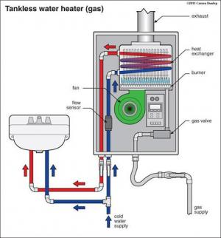 | WHY?  Often, high-efficiency endless hot water heaters can provide hot water at a rate of 2 to 5 gallons per minute. Other benefits include small size and longer life expectancy. These water heaters minimize wasted energy, producing lower-cost hot water that never runs out.
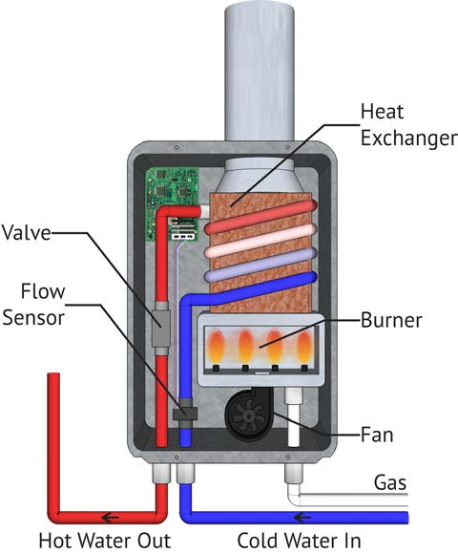 | HOW?  A gas tankless water heater’s basic components include a high-powered burner, fan, and heat exchanger. When a hot water tap is turned on, cold water enters the unit from the cold water supply and a sensor detects the water flow; then it activates a heating device, which raises the water temperature to a preset level. The heating element shuts off when the water flow from the fixture stops. These water heaters only consume energy when they are on.  When installing a tankless water heater, the unit should be level and rust-and corrosion-proof hardware should be used.
WATER HEATERS USE VARIOUS MEANS FOR FUEL: SOLAR WATER HEATERS

