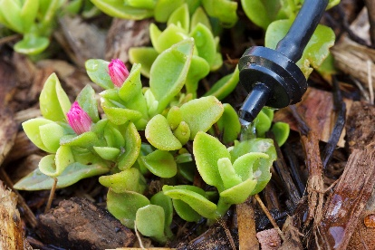 | WHAT?  Water-saving technology systems or “smart” irrigation control systems use local weather data to determine when and how much to water.  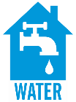
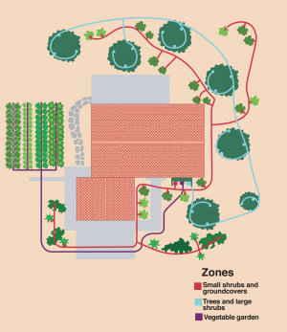 | WHY?  EPA estimates that more than 28 million US homes have in-ground sprinkler systems that typically schedule watering with a clock-based controller. Irrigation schedules are often set to water at the height of the growing season, and a homeowner may not adjust the schedule in light of seasonal changes or changes in plant watering needs. Drip irrigation systems use 20% to 50% less water than conventional sprinkler systems, achieving up to 30,000 gallons of water saved per year.
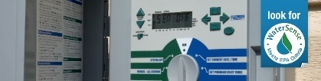 | HOW?  To earn the WaterSense label, smart irrigation technology must be able to adequately meet a landscape’s watering needs without overwatering by delivering low volumes of water directly to the plant's roots, minimizing losses to wind, runoff, evaporation, or overspray. Other options for reducing water use include control technologies that measure the moisture in the soil and adjust the irrigation schedule accordingly, rain sensors and rainfall shut-off devices that turn off irrigation on rainy days, and rotary spray sprinkler heads that lose less water to evaporation than misters.
WATER IS DISTRIBUTED TO THE SPRINKLERS: EFFICIENT LANDSCAPE IRRIGATION

