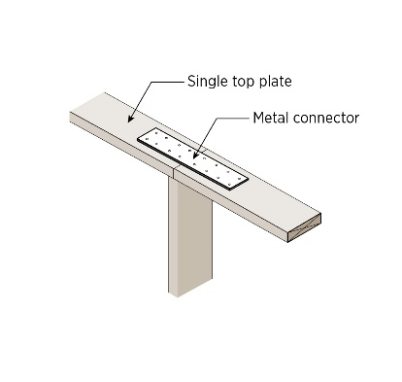 | WHAT?  When constructing walls with advanced framing, the top plate should consist of a single plate that’s connected using metal straps or wood splices. This approach helps save material and reduce thermal bridging.    
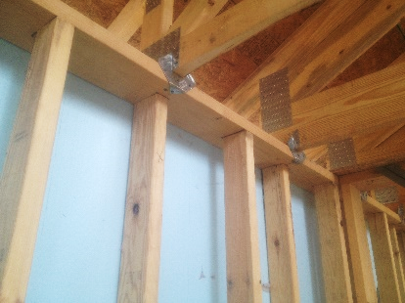 | WHY?  Adding more studs than necessary wastes lumber and reduces the wall’s thermal resistance because the lumber blocks cavity space that could be filled with insulation and because each stud represents a thermal bridge that can transfer heat between the interior and exterior of the building. Traditionally, walls are framed using double top plates. Using a single top plate saves lumber material and reduces thermal bridging without compromising the framing’s strength or integrity.
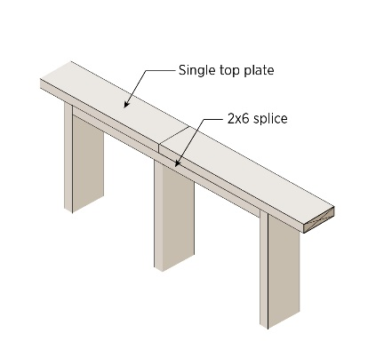 | HOW?  When designing advanced framed walls, specify single top plates in framing elevations. For an 8-foot wall, don’t purchase standard precut 92.5-inch studs; instead, purchase 8-foot (96-inch) studs and cut them to 94 inches. Connect top plates using either a metal plate or a wood splice.
FRAMING: WALL FRAMING: ADVANCED FRAMING & TOP PLATES

