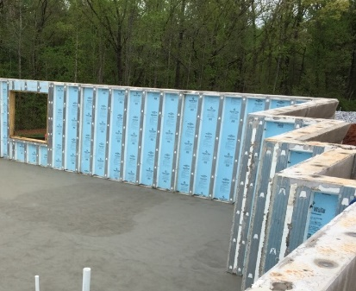 | WHAT?  The right type of vapor retarder—correctly installed in the right location—can help manage moisture and keep the home dry and healthy. Vapor retarders in basements are classified according to their ability to prevent moisture diffusion and should be specified based on climate and location in the building. They should not prevent water vapor from leaving the assembly.
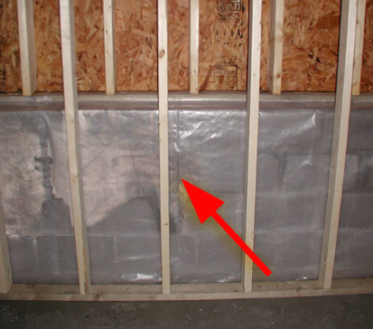 | WHY?  Insulating basements can help improve a home’s energy performance and comfort. However, the insulation must be installed in a way that doesn’t trap moisture in the walls. Often, wood-framed walls are installed against the concrete and the cavities are filled with fibrous insulation such as mineral wool, fiberglass, or cellulose insulation. If water vapor from the concrete can’t pass through, it may get trapped and lead to rot, mold, and other issues.
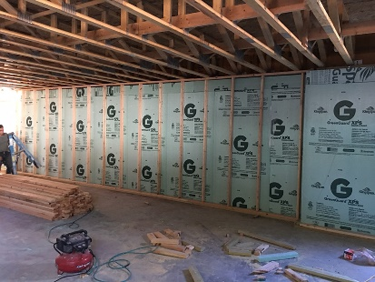 | HOW?  Class I vapor retarders are the least permeable type of vapor retarder. They include polyethylene plastic sheeting, rubber membranes, glass, aluminum foil, sheet metal, foil-faced insulating sheathings, and foil-faced non-insulating sheathings. They should not be used interior to fibrous insulation in basements and crawlspaces as they can trap moisture inside of wall assemblies. Instead, use Class II or Class III vapor retarders such as Kraft-faced fiberglass batts in the wall cavity or latex paint on the drywall for below-grade walls. Foam insulation can be used if the manufacturer’s specifications indicate a perm rating greater than 0.1 and if any wall finishes, such as latex paint, are vapor permeable.
INSULATION PROCESS/REQUIREMENTS: UNDERSTANDING VAPOR RETARDERS

