TYPES OF INSULATION

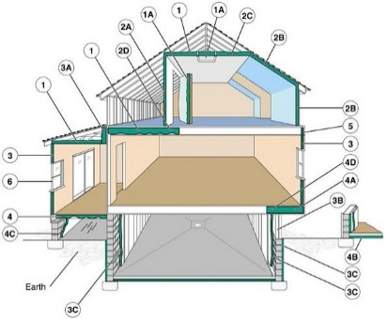 | WHAT?  As part of the whole-house systems approach, the building envelope needs to be air-sealed. Consider where the insulation is needed, the interaction between the insulation and other building components, and the need for moisture control. Builders need to know where to insulate and the recommended R-values for each area. Homeowners can install some types of insulation; other types require professional installation. When deciding on the type of insulation to use, other considerations may include indoor air quality impacts, life cycle costs, recycled content, embodied carbon, and ease of installation (especially if you plan to do the installation yourself).
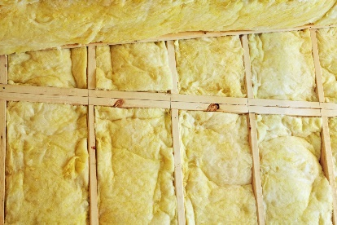 | WHY?  A properly insulated home not only reduces heating and cooling costs but also improves comfort. In most cases, a new home will save money and energy if you install a combination of cavity insulation and insulated sheathing.
HOW?
Insulation materials range from bulky fiber materials like fiberglass, rockwool, cellulose, and natural fibers to rigid foam boards to sleek foils. Bulky materials withstand conductive heat flow in the building cavity. Rigid foam boards trap air in their cells to withstand conductive heat flow. Highly reflective foils in radiant barriers and reflective insulation systems reflect radiant heat away from living spaces, making them especially practical in cooling climates. Other less common materials include cementitious and phenolic foams and perlite. The most common insulation materials work by slowing conductive heat flow and convective heat flow. Radiant barriers and reflective insulation systems work by reducing radiant heat gain; to work properly, the reflective surface must be in contact with an air space. Consider products that provide both insulation and structural support like structural insulated panels (SIPs) and insulating concrete forms (ICFs). Check with your contractor for more information about these options as well as other insulation options for your particular climate. Choose a team of local building professionals familiar with energy-efficient home construction as insulation performance is very dependent on the quality of installation.

