TUBS: CEMENT BOARD BEHIND TILE AND PANEL TUB AND SHOWER ENCLOSURES

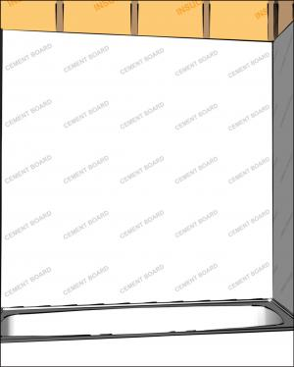 | WHAT?  Interior moisture management is pivotal for a home. Wet areas where water is intentionally brought into the home, such as bathrooms and kitchens, make moisture management more complicated. With walls behind tub and shower enclosures made of tile or panel assemblies with caulked joints, special protection is needed, so install cement board or an equivalent moisture-resistant backing material.
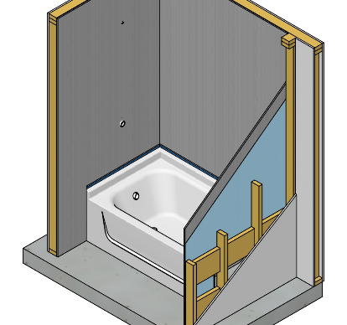 | WHY?  As with water seeping in from outside, unmanaged water inside the home can lead to many problems including mold, mildew, air quality issues, and even structural damage. This step is necessary for an effective and complete interior moisture management system.
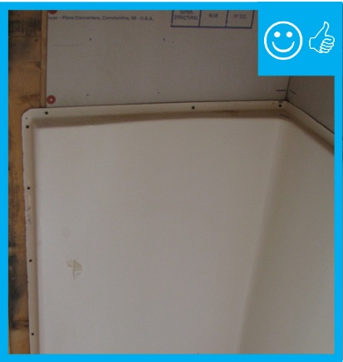 | HOW?  Confirm that the wall frames and cement boards are plumb to ensure that the ceramic tile will install correctly.  - If the tub or shower is on an exterior wall, make sure that any piping or wiring penetrations through the walls behind the tub and enclosure are tightly air-sealed and that the wall cavities are properly insulated. These items need to be done before installing cement board or equivalent.  - Measure the area for application.  - Using a circular saw fitted with an abrasive blade or a hand tool specific to the job and fitted with a carbide tip, trim the cement board to fit the measured space. Apply waterproofing to the entire and the edges.  - If the tub or shower is on an exterior wall and the cement board will serve as an air barrier over the insulation, apply a thick bead of caulk to the surface of the exposed studs and wood blocking as well as to the top and bottom plates, then nail or screw the air barrier material to the studs.  - Tape, seal, and mud any seams according to manufacturer specifications.  If installing an alternate product, use approved fiber-cement, fiber-reinforced gypsum, glass mat gypsum, or fiber mat-reinforced cementitious backer panels. Don’t use paper-faced paper-faced drywall behind seamed tub and shower enclosures. Per ENERGY STAR, if a monolithic tub and shower enclosure (e.g., fiberglass with no seams), a paper-faced backer board can be used if it meets ASTM mold-resistant standards.

