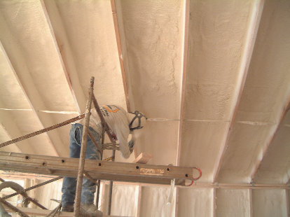 | WHAT?  A tight air-sealed home consists of insulation and a complete air barrier around the entire building envelope. It is accomplished by caulking and sealing around all cracks, holes, and other penetrations. A tight air-sealed home reduces leaks and air movement and improves energy and comfort. Air tightness can be measured using a blower door test.
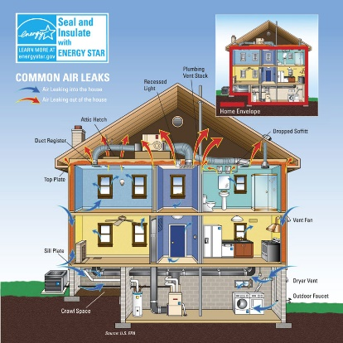 | WHY?  There are many pathways for air to leak through a home’s building envelope. Poorly air-sealed homes are less comfortable and cost more to maintain because they provide a pathway for drafts, cold spots, moisture, and insects into the home. Comprehensive draft protection minimizes air flow that can undermine a complete high-performance insulation system. Air-sealing can reduce utility costs while improving comfort, indoor air quality, noise control, and durability.
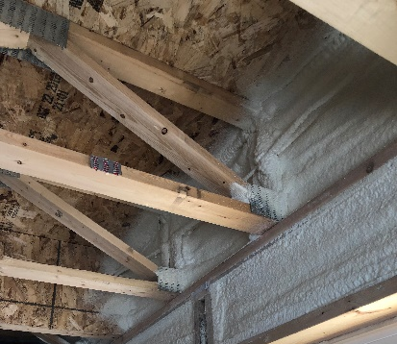 | HOW?  Comprehensive draft protection includes a continuous air barrier around the whole house, along with caulking and sealing in all holes and cracks. This includes around wiring, plumbing, ducts, and flues; where wall framing meets flooring; around windows; where drywall meets top plates and sill plates; where rim joists meet foundation walls and subfloors; etc. Spray foam insulation can be used at rim joists, floors above unconditioned space, and in attics to insulate and air seal at the same time.
INSULATION PROCESS/REQUIREMENTS: TIGHT AIR-SEALED HOME

