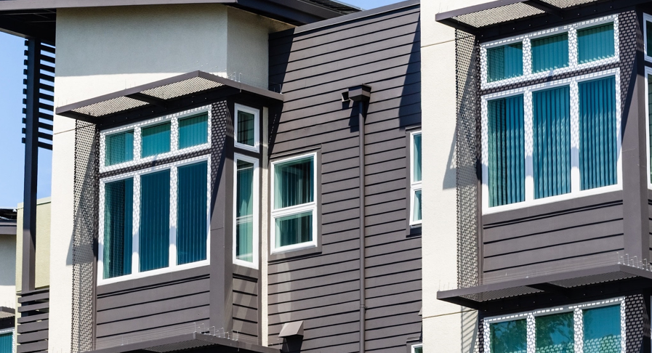 | WHAT?  A common wall, also known as a party wall, fire wall, fire separation wall, townhouse separation wall, or tenant separation wall, can be described as a fire-resistance rated wall that extends continuously from the foundation to the underside of fire protected roof sheathing. These are most common in multi-family units.
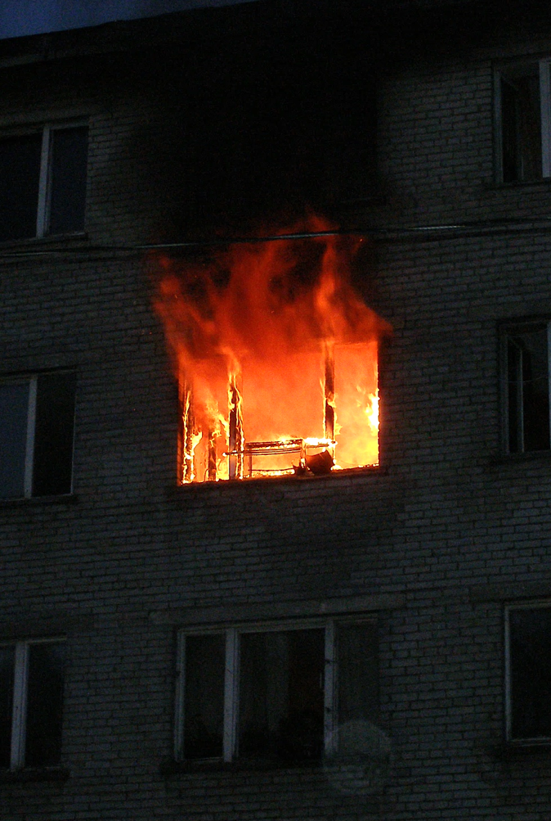 | WHY?  The purpose of a common wall is to prevent the spread of fire from one unit to another, and to allow the collapse of a unit that is on fire without structurally impacting the adjacent unit.  Proper air sealing this common wall is critical in a fire situation because it allows less transfer of smoke and hot gas in one direction, and less oxygen to feed the fire in the other direction.  Other benefits to a well-sealed party wall:  - Energy efficiency and comfort is improved by reducing infiltration and the energy required to condition that air.  - IAQ is improved by reducing odor and contaminated air transfer from adjacent units or common areas.  - Reduced sound transfer between units.  - If lobby doors or unit windows are left open, air-sealing greatly reduced or eliminates the chimney or stack effect upward through the building.
 | HOW?
THE IMPORTANCE OF DRAFTSTOPPING AND FIREBLOCKING PARTY WALLS

