THE BASICS OF CORE PLUMBING LAYOUT
WHAT?
Traditional hot water distribution systems consist of a trunk and
branch layout which entails a relatively long, large-diameter
main line feeding smaller branches that flow to plumbing
fixtures or split to serve multiple fixtures. This design can lead to
higher energy bills, wasted water, and wasted time for the
occupant.
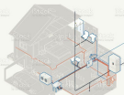
WHY?
Even in relatively small homes of 1,200 square feet, the volume
of water in the pipes to the furthest fixture can exceed 1.5
gallons and the time to the tap can be more than 90
seconds. Letting the water flow until it is at the desired
temperature can waste 3 gallons of water uses enough energy
to power a 60-watt light bulb for 12 hours.
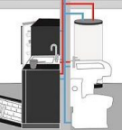
HOW?
A core plumbing layout for hot water distribution is a building
designed so that all rooms using water (e.g., kitchen,
bathrooms, and laundry room) are placed in close proximity to
the water heater. This results in hot water piping to each
plumbing fixture and appliance in as direct a path as possible.
The more direct the route the less wasted water and quicker
time to tap.

