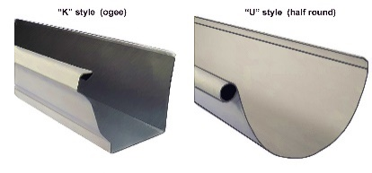 | WHAT?  Just a few inches of rain falling on a house’s roof can produce several thousand gallons of water runoff, which must be channeled away from the building foundation to keep the basement or crawlspace dry and to prevent water from seeping into the building’s interior where it may create moisture problems. Good water management practices safeguard the foundation from water saturation.
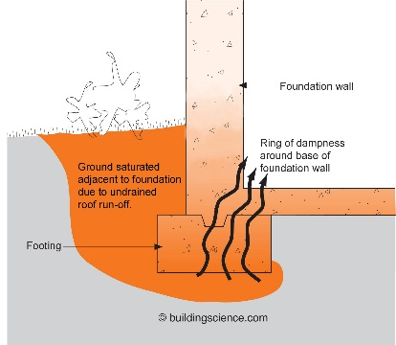 | WHY?  If not drained away from the house, the high volume of water coming off the roof can quickly saturate the soil surrounding the building and wick through the foundation to the interior. This can lead to a variety of problems with mold and rot, indoor air quality issues, and durability of the building. Install gutters and downspouts on a home to direct rainwater down and away from the building and to reduce the chances of saturating the soil around the foundation. An exterior system complete with climate-appropriate flashing, overhangs, and drainage planes is particularly important to keep water away from the building foundation in areas with expansive and/or collapsible soils.
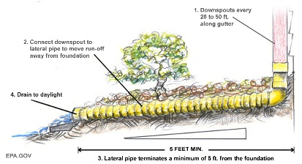 | HOW?  There are four options for accommodating rainwater runoff from a roof:  - Install gutters and downspouts terminating at least 5 feet away from the foundation.  - Install gutters and downspouts terminating to an underground catchment system at least 10 feet away from foundations.  - Install a rainwater harvesting system that has a drain to adequately handle the overflow and meet discharge distance requirements.  - Instead of gutters, install a grade-level rock bed around the home with a drain pipe in a lined trench beneath the bed to carry water to a sloping finish grade at least 5 feet from the foundation, or to a drywell or other approved location; splashback damage protection is also required.  There are also methods to install protection from water splash damage for homes without gutters (per EPA).
STORMWATER: GUTTERS AND DOWNSPOUTS

