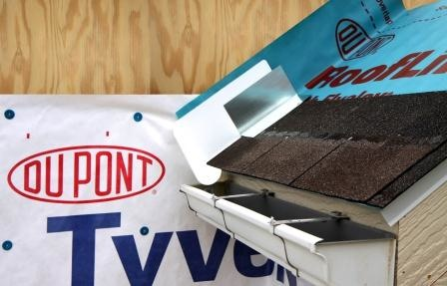 | WHAT?  Step flashing should be installed any time the roof intersects with a wall, such as a dormer. This flashing protects walls from water intrusion.
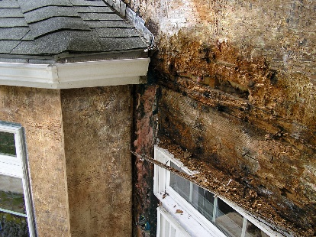 | WHY?  Heavy rains can pour thousands of gallons of water onto a home’s roof in a single storm. Where roofs intersect walls, much of this water is channeled off the roof and into gutters. If sidewall flashing is lacking or inadequate, water can leak into the wall and cause serious water damage.
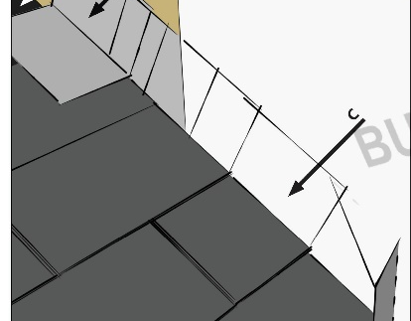 | HOW?  Step flashing is often made of corrosion-resistant metal. It should extend at least 4 inches up the wall from the roof deck and at least four inches out along the roof deck. The flashing is integrated with the roof and wall drainage planes in shingle fashion, so that the top layer of the WRB or flashing laps over the bottom layer.
ROOFING: STEP FLASHING AT ROOF-WALL INTERSECTIONS

