SPRINKLER SYSTEM INSTALLED: SPRINKLER IRRIGATION

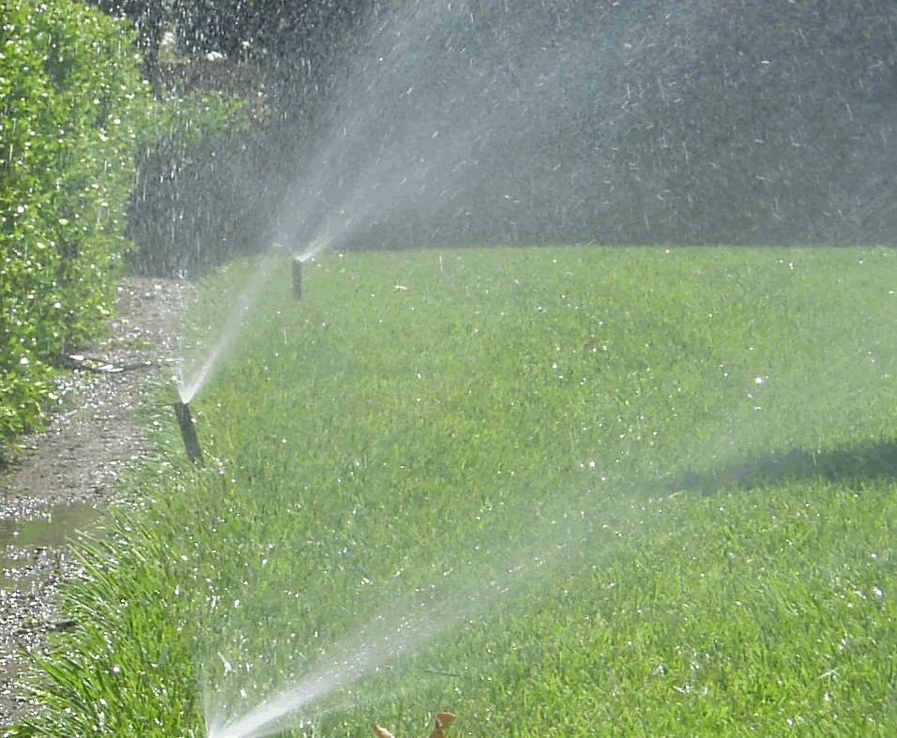 | WHAT?  Sprinkler irrigation refers to types of irrigation that use sprinklers to distribute needed water by converting water pressure to high-velocity discharge streams. This type of irrigation can be utilized to distribute water evenly over uniformly planted areas of turfgrass.  Shrubs, trees, plant beds, and any other non-turf landscape should be watered using micro-irrigation, which supplies water directly to plant roots and reduces overspray and runoff.
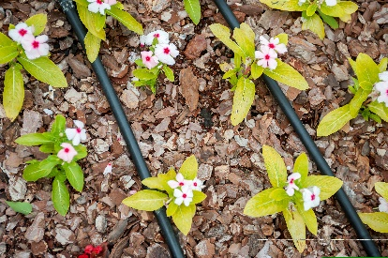 | WHY?  Properly using sprinkler irrigation and micro-irrigation, along with installing water-saving landscaping, means avoiding wasting thousands of gallons of water each year. A solid irrigation strategy also means money saved on water bills.
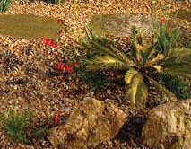 | HOW?  Designing a system with matched precipitation nozzles is important for water efficiency and ensures that all areas of the landscape are watered at the same rate. This concept is especially important when a landscape has sprinklers with varying coverage (e.g., half-arc and quarter-arc sprinklers). An irrigation system installer can match the precipitation rate of the sprinkler heads in the irrigation system by calculating the precipitation rates and coupling similar heads in the same zone.  EPA’s WaterSense program requires that sprinkler heads have a 4-inch or greater pop-up height and matched precipitation nozzles. The program specifies that sprinkler irrigation should not be used on strips of turfgrass less than 4 feet wide, nor on slopes in excess of 4 feet of horizontal run per 1-foot vertical rise (4:1) where micro-irrigation is the best choice.  The installer should make sure that sprinkler head spacing is consistent, flow rates are based on coverage, and the pipes deliver water at a uniform pressure to each unit.

