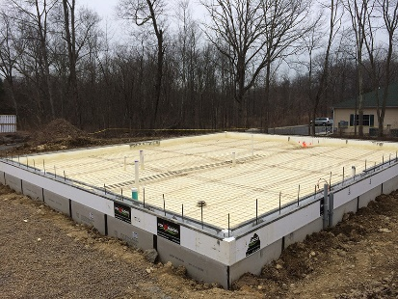 | WHAT?  In cold climates, it’s important to install insulation along the edge of slab-on-grade foundations. Installing insulation here can help meet or exceed the insulation R-value required by code. The rigid insulation is installed from the top of the slab down to the required depth. For slabs that are poured separately from foundations, the insulation is installed before the concrete is poured.
WHY?
Poorly or incorrectly insulated foundation slabs can cause several problems. Energy is lost when heat is conducted through the perimeter of the slab and into the surrounding soil. Moisture can become an issue inside the house if the difference between the slab temperature and indoor air temperature is too great. Condensation can promote mold growth and compromise indoor air quality.
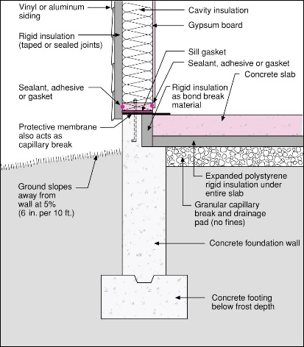 | HOW?  When the slab is monolithic with a grade beam, the insulation must be installed to the exterior of the slab edge and continue vertically to the bottom of the grade beam. Note that different regions may have different code requirements. The insulation material must be appropriate for ground contact. XPS, rigid fiberglass, and rock wool are all acceptable.  When the slab is independent from a perimeter foundation wall, the slab must be thermally isolated from the foundation by installing insulation at the slab edge and under the slab perimeter.
INSULATION CODE: SLAB EDGE INSULATION

