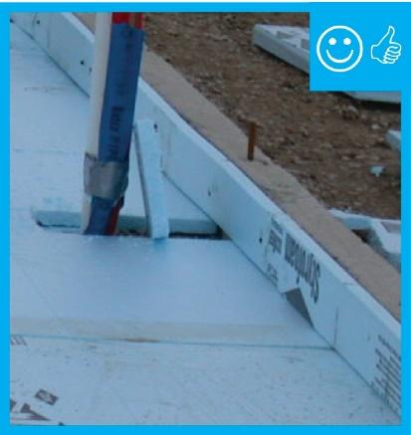 | WHAT?  In cold climates, rigid insulation is installed on the edge of slabs during the construction of the slab. The insulation must extend to the top of the slab. Proper installation minimizes thermal bridging, moisture, and air quality issues and can help create high-performance homes.
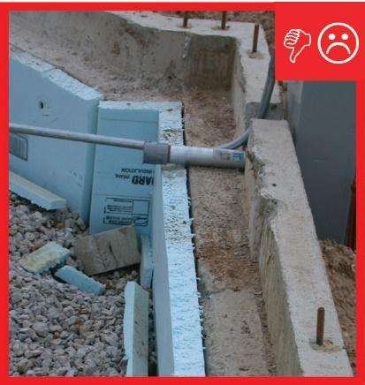 | WHY?  Poorly or incorrectly insulated foundation slabs can create several problems in homes. Energy can be lost when heat is conducted outward through the perimeter and into the surrounding soil. Moisture can become an issue if the difference between the slab and indoor air temperatures become too great. Condensation can promote mold growth and compromise indoor air quality.
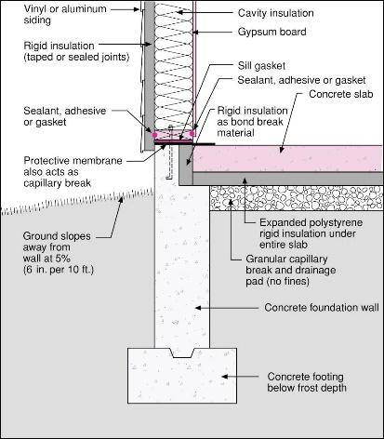 | HOW?  For a monolithic slab with a grade beam, the insulation must be installed to the exterior of the slab edge and continue vertically to the bottom of the grade beam. Note that different regions may have different code requirements. The insulation material must be appropriate for ground contact; XPS, rigid fiberglass, and rock wool are all acceptable. For slabs that are independent of the foundation, the slab must be thermally isolated from the foundation by installing insulation at the slab edge and under the slab perimeter.
INSULATION PROCESS/REQUIREMENTS: SLAB EDGE INSULATION

