SLAB EDGE INSULATION

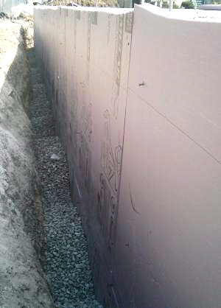 | WHAT?  Part of constructing and insulating slab-on-grade foundations in cold climates is installing slab edge insulation. Ultra-efficient insulation is 25% more efficient than the national code (IECC 2015). Installing ultra-efficient insulation properly achieves conditioned spaces that require very little heating and cooling, along with increased comfort and quiet throughout the house.
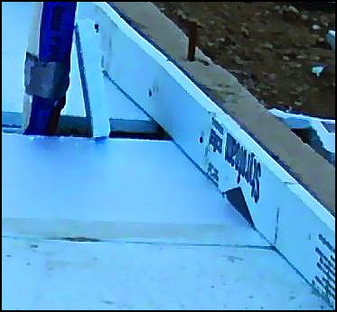 | WHY?  Poorly or incorrectly insulated foundation slabs can result in several problems for homes, including energy loss, moisture control problems, and indoor air quality issues.  Often, rigid insulation is installed during the construction of the slab, but it is done incorrectly or incompletely. By properly installing rigid insulation that extends to the top of the slab in either a monolithic slab with a grade beam or a slab independent of the foundation design, these challenges can all be minimized.
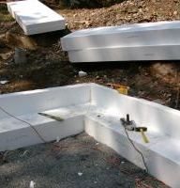 | HOW?  - Install insulation along the edge of the slab so that the slab-on-grade foundation meets or exceeds the insulation R-value specified by code.  - Install insulation from the top of the slab down to the depth as specified.  If the slab is poured separately from the exterior foundation wall and the slab edge insulation is installed between the floor slab and the foundation wall, code allows for the top of the foam to be cut at a 45-degree angle away from the exterior wall so that the upper edge is protected by concrete.

