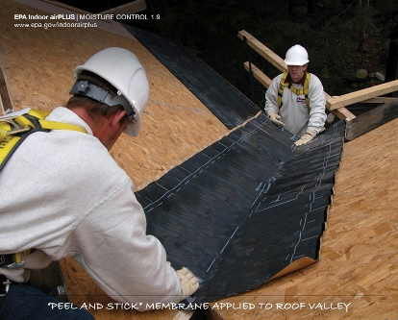 | WHAT?  Sealing roof valleys can help prevent water from infiltrating these vulnerable areas. Sealing is accomplished by installing a self-sealing membrane such as a bituminous peel-and-stick material on the roof sheathing surface beneath the roofing felt.
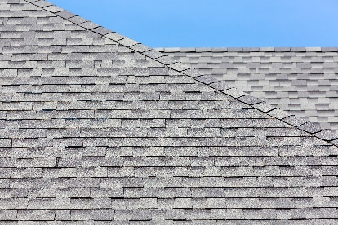 | WHY?  The roof is the house's primary defense against water intrusion from rain, snow, and ice. It must be designed and constructed to shed water effectively through all seasons, including extreme weather events. Water that leaks into the house through the roof can quickly damage insulation, create conditions for mold growth and pest invasion, and even lead to structural rot. Valleys are among the most vulnerable areas for water intrusion.
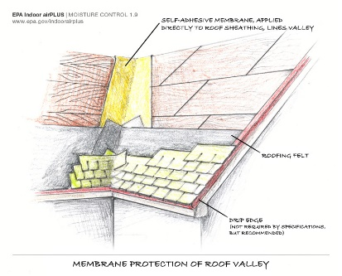 | HOW?  Valleys should be sealed along their entire length. Before installing the membrane, the roof deck sheathing must be clean. The membrane should be applied from the lowest point to the highest, overlapping membrane sections by 6 inches in shingle fashion. This allows water to flow unobstructed down the length of the valley. It should be centered on the valley line and lay flat with no gaps, creases, or folds.
ROOFING: SEALING ROOF VALLEYS

