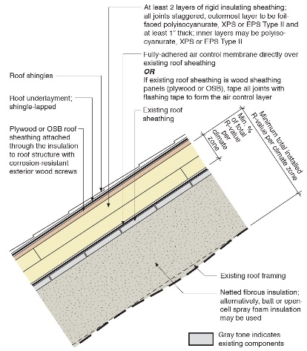 | WHAT?  A roof cladding substrate can be installed over layers of exterior rigid insulation to provide a nailbase for roof cladding material a solid substrate for fasteners. This substrate usually consists of plywood or OSB roof sheathing.
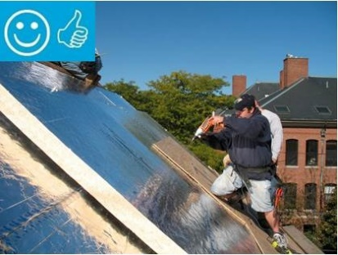 | WHY?  A retrofit that involves re-roofing provides a great opportunity to install rigid foam insulation above the roof deck. This can help achieve a high R-value roof enclosure that offers robust water control while providing a conditioned, unvented attic space for storage and for housing the home’s HVAC system and/or ducts. Because one or more rigid foam layer are installed on top of the roof deck, it is necessary to provide a nailbase substrate for the roof cladding.
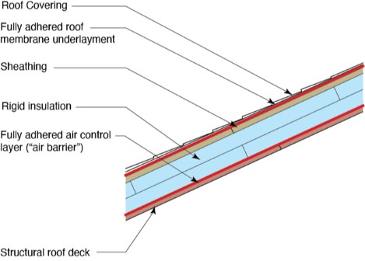 | HOW?  An unvented roof cladding substrate, consisting of plywood or OSB roof sheathing, can be installed over exterior insulation layers using long exterior-grade screws. The screws must be long enough to penetrate an adequate depth into the roof framing. It’s important to mark the location of framing on each successive layer, especially when the framing has irregular spacing. Install roof underlayment, flashing, and cladding on top of the substrate as per best practices.
ROOFING: ROOF CLADDING SUBSTRATE WITH RIGID INSULATION

