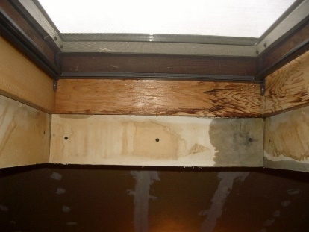 | WHAT?  Repairing or replacing an existing skylight can improve both water resistance and performance. The unit should be replaced if it is damaged, relatively old, or does not meet the project performance goals for insulation value, solar heat gain, and air sealing. Checking for leaks and water damage is an essential step for determining whether to replace or repair a skylight.
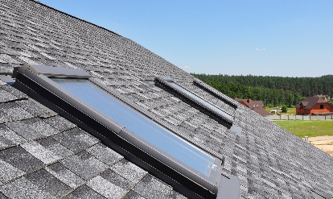 | WHY?  Skylights are penetrations through a roof’s water control layer. Weathering of components and improper installation can lessen the effectiveness of the water control layers around the skylight, allowing leaks to occur. New skylights can provide improved air tightness, energy efficiency, and condensation resistance. Installers should inspect the skylights for signs of leakage, and to determine if proper flashing and other water management details are in place to prevent future water leaks.
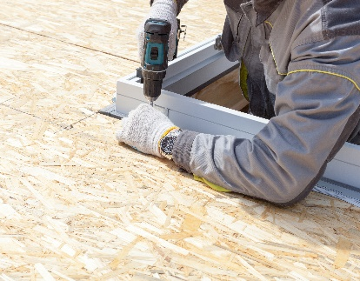 | HOW?  There are three main issues that warrant replacement of existing skylight units:  The insulated glass unit fails because of long-term exposure to water. This problem is identified by condensation between the inner and outer panes of glass.  There are leaks through joints in the frame. This problem is identified by inspecting the frame and sash for signs of water leakage at the interface of the framing members.  There are leaks through the gaskets or weather stripping in operable units. This is determined by inspecting the gaskets or weather stripping between the sash and the frame to make sure it isn’t missing, damaged, or worn.
ROOFING: REPLACING EXISTING SKYLIGHTS

