SITE EXCAVATION: STORMWATER MANAGEMENT

WHAT?
A sustainable stormwater management plan for a new energy-efficient home requires understanding of the site and how water works in the landscape and climate. Stormwater must be channeled away from the construction site to prevent pollution and from the finished building’s foundation to keep the basement or crawlspace dry and block water from the interior.

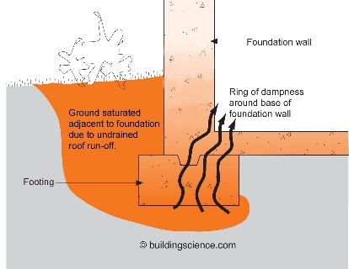 | WHY?  If not drained away from the house, the high volume of water coming off the roof can quickly saturate the home’s surrounding soil and wick through the foundation. A variety of problems involve mold and rot, indoor air quality, and building durability.
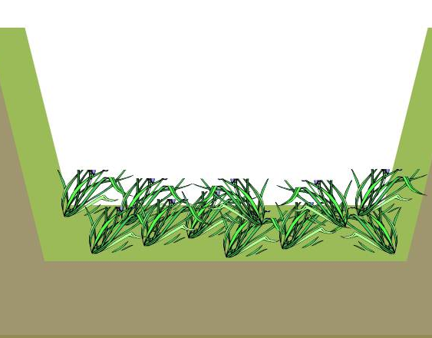 | HOW?  Slope grade away from the house. Install gutters and downspouts on the home to direct rainwater down and away from the building and to reduce the chances of saturating the soil around the foundation. A complete exterior system with climate-appropriate flashing, overhangs, and drainage planes is particularly important to keep water away from the building foundation in areas with expansive and/or collapsible soils.  Consider using vegetated swales, which are gently sloping landscaped depressions that collect and convey stormwater runoff. They are narrow and at least 100 feet in length, and their dense plants filter stormwater and infiltrate water into the ground. They may discharge to a storm sewer or other location where soils don’t drain as well.

