SITE IS EXCAVATED: FINAL GRADE IS SLOPED AWAY FROM HOME
WHAT?
The final grade needs to slope away from the house to protect the home’s foundation.

WHY?
Stormwater can cause sizeable damage to a home, and building materials that are allowed to remain damp or saturated for long periods of time will eventually fail. One of the ways to protect the home’s foundation is to properly grade the site so water drains away from the home on all sides and damp-proof the exterior of foundation walls.

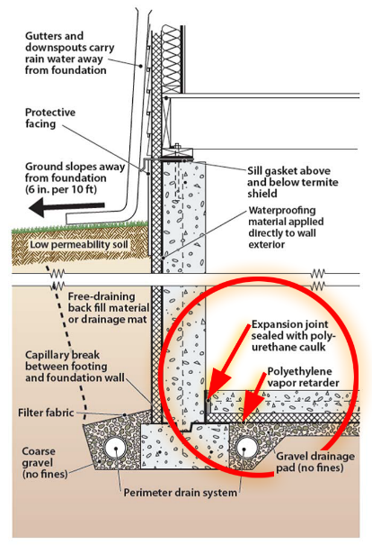 | HOW?  Construct the foundation and grade the site so that water drains away from the house on all sides. To guide stormwater runoff away from the foundation:  - Slope the final grade away from the house (at minimum 0.5 inch per foot for 10 feet).  - If necessary, grade to build up the site before construction to create a slope that will carry water down and away from the foundation from all sides.  - Excavate, then install foundation footings, stem wall, and slab. Put in footing drain pipe, waterproofing, and exterior insulation.  - After construction, backfill to the foundation walls, grade the slope, cap the top layer of the grade with 2 to 4 inches of silty clay, and mechanically compact (tamp) the soils to prevent settling.  Tamping is not required if either proper drainage can be achieved using non-settling compact soils (a certified hydrologist, soil scientist, or engineer would decide this) or the builder has scheduled a site visit to provide in-fill and final grading after settling may have happened (e.g., after the first rainy season). Per ENERGY STAR, if setbacks limit the space to less than 10 feet, install either swales or drains designed to conduct water away from the foundation.

