CONCRETE IN FOUNDATION WALLS IS DAMP-PROOFED AND WATERPROOFED

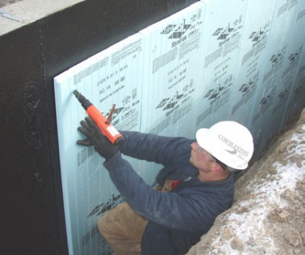 | WHAT?  After the final grade is sloped away from the home, the exterior of foundation walls needs to be damp-proofed and waterproofed to protect the foundation.
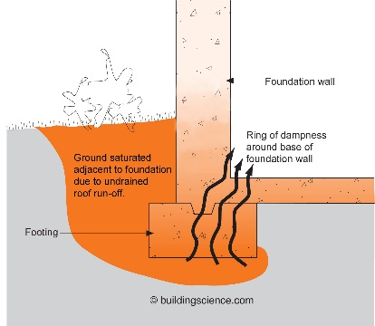 | WHY?  Porous concrete foundations should be treated to avoid water seepage into the home as well as very costly repairs. This step is part of a comprehensive set of measures that minimize the risk of water damage.
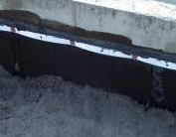 | HOW?  Treat below-grade walls with a damp-proof coating such as an asphalt emulsion. For additional protection, a plastic drainage plane may be used instead of (or in combination with) the damp-proof coating. The surface coating may then be joined by a layer of insulation—preferably rigid fiberglass or rigid polyurethane foam rated for soil contact. Add a gravel layer to provide a good backfill for draining and allow water to flow toward the foundation footing where a perforated drain pipe will carry it away from the structure.

