BASEMENT SLAB INSULATION EDGE

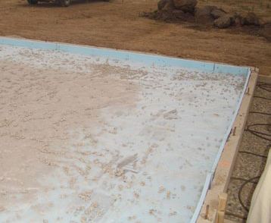 | WHAT?  Along with a sloping grade and waterproofed foundation walls, the foundation slabs need to be properly insulated in order to protect the foundation.
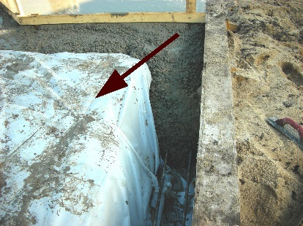 | WHY?  Poorly insulated foundation slabs can present several problems involving energy loss, moisture control, and indoor air quality. Energy loss typically happens because of heat conducted outward through the perimeter of the slab and into the surrounding soil. Moisture can become an issue inside the house when relative temperature differences between the slab and indoor air temperatures become too great and condensation or high localized relative humidity issues occur. With condensation present, mold may have a chance to grow and create indoor air quality issues.
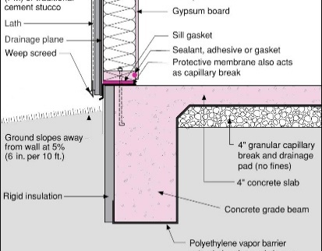 | HOW?  Properly install rigid insulation that extends to the top of the slab in either a monolithic slab with a grade beam or a slab independent of the foundation design.  - Make sure the insulation is approved for below-grade use.  - Review the plan for slab insulation with pest control and local building officials to achieve compliance.  - Confirm that insulation levels meet or exceed state and IECC requirements.

