POST-TENSIONED SLAB POUR

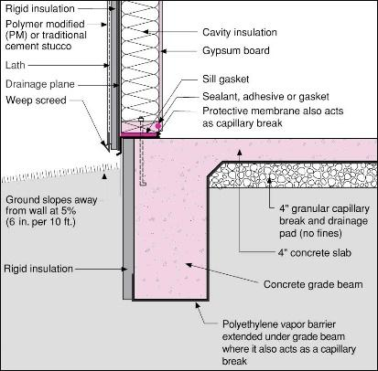 | WHAT?  To minimize thermal bridging, apply foam insulation to footed walls before post-tensioned slabs are poured.
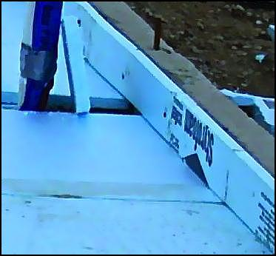 | WHY?  Foam insulation provides good insulation but also a quality air and water barrier when applied over and under a compacted crushed-stone base (R-10 or more is a good number). This step improves energy efficiency and occupant comfort.
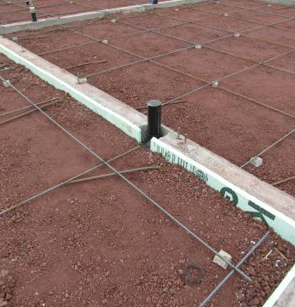 | HOW?  To provide insulation and air sealing, place a layer of foam insulation under the slab and also under the footings. Before pouring the post-tensioned slab, cover the footing walls’ interior perimeter with about two inches of foam insulation.  The vapor barrier should be located on the top of the rigid insulation, between the rigid insulation and the bottom surface of the concrete. The vapor barrier should never be UNDER the insulation as it will keep the insulation wet.

