Building Science Education Solution Center—Plumbing

Proficiency Level 3: Apply

Learning Objective 3.1
- Sketch the general configuration of the typical for trunk and branch, core, whole-house manifold, and demand hot water delivery system types and explain the overall concept of each design.

Lecture Notes 3.1
The following notes are from U.S. Environmental Protection Agency. July 24, 2014. WaterSense® New Home Specification Guide for Efficient Hot Water Delivery System. EPA WaterSense. https://www.epa.gov/sites/production/files/2017-01/documents/ws-homes-hot-water-distribution-guide.pdf

Trunk and branch systems are characterized by one long, large diameter main line (i.e., the “trunk”) that runs from the water heater to the farthest fixture in the house. As illustrated in Figure 1, along the way, “branches” from the main trunk supply hot water to various areas of the home, and smaller “twigs” branch off to supply hot water to individual fixtures. Typically, the main trunk uses larger diameter piping to ensure adequate flow, with smaller diameter piping branching off to individual fixtures.

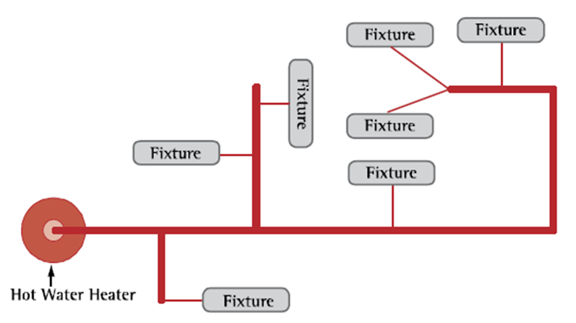

Figure 1. A General Configuration Typical of Trunk and Branch Systems

Trunk and branch systems are the most common type of hot water delivery system. They can be utilized in both single- and multi-family homes. In terms of maximizing hot water delivery system efficiency, trunk and branch systems are most suitable for smaller homes, homes with relatively few fixtures, or in multi-family housing if installed individually in each unit. It may be difficult to design an efficient trunk and branch system in larger homes with spacious layouts and a large number of fixtures. Of all of the hot water delivery systems presented in this guide, trunk and branch systems have the greatest potential to be inefficient, if care is not taken to centralize fixture placement and minimize pipe run lengths.

Core Systems

Core systems utilize a central plumbing core, where plumbing areas (i.e., kitchens, bathrooms, laundry rooms) are placed in close proximity to the water heater. Hot water is piped directly to each fixture or group of fixtures using smaller diameter piping when appropriate and as direct a path as possible. Figure 2 illustrates the main design principles of this configuration. As the figure shows, the relative proximity of the fixtures and direct horizontal runs minimizes the length of piping and the amount of time required for hot water to reach each fixture.

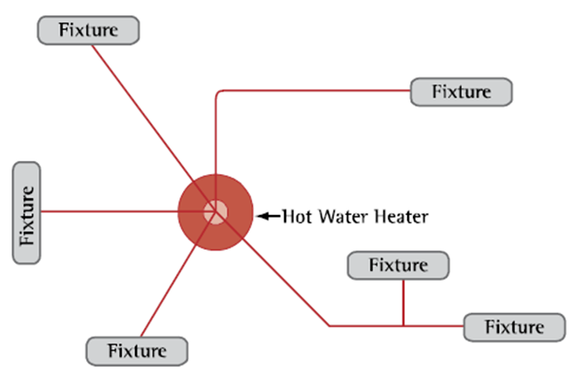
Figure 2. A General Configuration Typical of Core Systems

Because core systems use less—and smaller diameter—piping, they can significantly reduce conductive heat loss and the amount of water that users waste waiting for hot water to arrive at the fixtures. They can also be made with any type of piping (or multiple types if necessary); copper, CPVC, and cross-lined polyethylene (PEX) are the most commonly used types. As a result, core systems provide greater flexibility and can be less expensive and quicker to install relative to other system types.

Whole-House Manifold Systems

Whole-house manifold systems, also called parallel pipe or home run systems, use small diameter, flexible piping (such as PEX) that run directly to each individual fixture from a central manifold. As shown in Figure 3, the central manifold is typically kept in close proximity to the water heater. The manifold may be constructed of either plastic or metal.

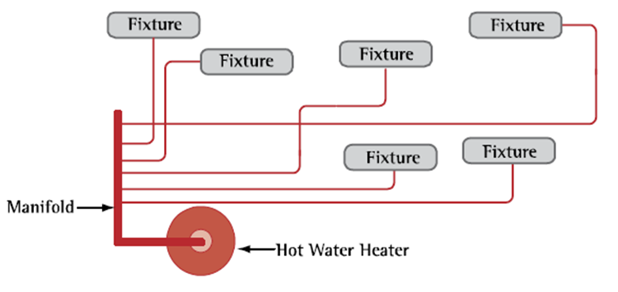
Figure 3. A General Configuration Typical of Whole-House Manifold Systems

Demand-Initiated Recirculation Systems

Recirculation systems consist of one continuous hot water supply loop that recirculates water throughout the home. As shown in Figure 4, a circulating pump draws hot water through the recirculation loop and returns to the water heater any ambient-temperature water residing within the loop. Alternately, the pump may return this water to the cold water line while simultaneously drawing hot water from the water heater.
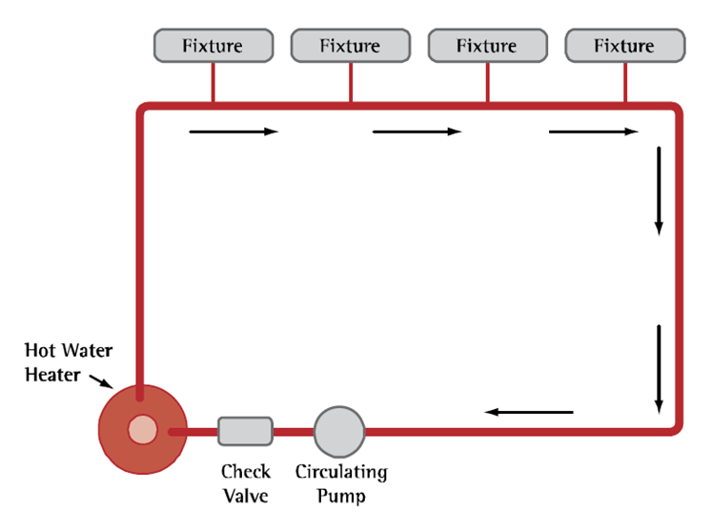
Figure 4. A General Configuration Typical of Demand-Initiated Recirculation Systems

Demand-initiated recirculation systems have been found to be more energy-efficient than other timer- or temperature-based recirculation systems, because hot water is only drawn into the recirculation loop when hot water is needed. Demand-initiated systems use sensor electronics installed at the fixtures to automatically adjust standing ambient temperatures in the hot water recirculation loop. When the user activates the pump by pushing a button, or via a motion sensor located near the hot-water fixture, the sensor measures temperature changes in the recirculation loop and activates the circulating pump until the water in the loop reaches a specified temperature, at which time the water is delivered to the fixture.

It is important to note that timer- and temperature-based recirculation systems may not be used to meet WaterSense® new home specification criteria. Research indicates that these systems can use a large amount of energy to maintain the water temperature in the recirculation loop and are considered to be energy-inefficient.

Learning Objective 3.2
- Identify and compile a list of the key plumbing building codes for a residential building in your climate zone.

Lecture Notes 3.2
Note that the specific codes can be found at the links below.

When designing, installing, or remodeling a water plumbing system, it is essential to work with a state-licensed plumber and to follow local and state building codes and plumbing standards for your specific climate zone. Learn more about the International Residential Code (IRC) at https://www.iccsafe.org/codes-tech-support/codes/2015-i-codes/irc/ , the Uniform Plumbing Code (UPC) at http://codes.iapmo.org/home.aspx?code=UPC, the International Energy Conservation Code at https://www.iccsafe.org/codes-tech-support/codes/2015-i-codes/iecc/ and the International Plumbing Code (IPC) at https://www.iccsafe.org/codes-tech-support/topics/plumbing-mechanical-and-fuel-gas/international-plumbing-code-ipc-home-page/

Forty-four states require plumbers to be licensed plumbing contractors. To become licensed in a specific area a contractor must pass exams and meet certain criteria to prove competency in a trade.

Codes – specify how buildings must be constructed or perform, and are written in mandatory, enforceable language. States or local governments adopt and enforce codes for their jurisdictions.

Standards – describe how buildings should be constructed to save energy cost-effectively. They are published by organizations such as the American Society of Heating, Refrigerating, and Air-Conditioning Engineers (ASHRAE). They are not mandatory, but serve as national recommendations, with some variation for regional climate. States and local governments frequently use energy standards as the technical basis for developing their energy codes. Some energy standards are written in mandatory, enforceable language, making it easy for jurisdictions to incorporate the provisions of the energy standards directly into their laws or regulations.

Primary code organizations that provide codes related to plumbing are as follows:

- The International Residential Code (IRC)--This comprehensive, stand-alone residential code establishes minimum regulations for one- and two-family dwellings and townhouses using prescriptive provisions. It is founded on broad-based principles that make possible the use of new materials and new building designs. The IRC contains a complete set of code provisions, covering all aspects of construction in a single source, including: building, energy conservation, plumbing, mechanical, fuel gas provisions included through an agreement with the American Gas Association, and electrical provisions from the 2014 National Electrical Code® (NFPA 70). The principles of the IRC are based on protection of public health, safety and welfare
- The Uniform Plumbing Code (UPC)—This code includes all potable water, building supply, and distribution pipes; all plumbing fixtures and traps; all drainage and vent pipes; and all building drains, and building sewers, including their respective joints and connections, devices, receptors, and appurtenances within the property lines of the premises and shall include potable water piping, potable water treating or using equipment, medical gas and medical vacuum systems, liquid and fuel gas piping, and water heaters and vents for same. The UPC established minimum requirements and standards for the protection of the public health, safety and welfare. The provisions of this code apply to the erection, installation, alteration, repair, relocation, replacement, addition to, use, or maintenance of plumbing systems within the jurisdiction.
- International Energy Conservation Code (IECC)—This comprehensive energy conservation code establishes minimum regulations for energy-efficient buildings using prescriptive and performance-related provisions. It is founded on broad-based principles that make possible the use of new materials and new energy-efficient designs. This IECC is fully compatible with the Family of International Codes. The International Energy Conservation Code is in use or adopted in 47 states, the District of Columbia, the U.S. Virgin Islands, New York City and Puerto Rico.
- International Plumbing Code (IPC)—This code is a proven, comprehensive model plumbing code that works seamlessly with ICC's family of building codes. It sets minimum regulations for plumbing systems and components to protect life, health and safety of building occupants and the public. The IPC is available for adoption by jurisdictions ranging from states to towns, and is currently adopted on the state or local level in 35 states in the United States.

