Building Science Education Solution Center—Plumbing

Proficiency Level 2: Understand

Learning Objective 2.1
- Identify eight materials used for pipes in plumbing. For three of these materials, describe a positive attribute or use. For the other three materials, describe a negative attribute or why some local codes may prohibit this material for water supply piping.

Lecture Notes 2.1
The following lecture notes are from Center for Disease Control and Prevention (CDC) and U.S. Department of Housing and Urban Development (HUD). Healthy Housing Reference Manual. 2006 [with 2012 pdf link but 2006 date in report]. U.S. Department of Health and Human Services, Atlanta, GA. https://www.cdc.gov/nceh/publications/books/housing/housing_ref_manual_2012.pdf

Care must be taken when choosing the piping materials. Some state and local plumbing codes prohibit using some of the materials listed below in water distribution systems.

Polyvinyl Chloride (PVC). PVC is used to make plastic pipe. PVC piping has several applications in and around homes such as in underground sprinkler systems, piping for swimming pool pumping systems, and low-pressure drain systems. PVC piping is also used for water service between the meter and building. PVC, or polyvinyl chloride, is one of the most commonly used materials in the marketplace.

Chlorinated PVC (CPVC). CPVC is a slightly yellow plastic pipe used inside homes. It has a long service life, but is not quite as tough as copper. Some areas with corrosive water will benefit by using chlorinated PVC piping. CPVC piping is designed and recommended for use in hot and cold potable water distribution systems.

Copper. Copper comes in three grades:
- M for thin wall pipe (used mainly inside homes);
- L for thicker wall pipe (used mainly outside for water services); and
- K, the thickest (used mainly between water mains and the water meter).

Copper lasts a long time, is durable, and connects well to valves. It should not be installed if the water has a pH of 6.5 or less. Most public utilities supply water at a pH between 7.2 and 8.0. Many utilities that have source water with a pH below 6.5 treat the water to raise the pH. Private well water systems often have a pH below 6.5. When this is the case, installing a treatment system to make the water less acidic is a good idea.

Galvanized Steel. Galvanized pipe corrodes rather easily. The typical life of this piping is about 40 years. One of the primary problems with galvanized steel is that, in water with high concentrations of calcium, the pipe will become severely restricted by corrosion that eventually fills the pipe completely.
Another problem is that the mismatch of metals between the brass valves and the steel results in corrosion. Whenever steel pipe meets copper or brass, the steel pipe will rapidly corrode.

PEX. PEX is an acronym for a cross-formulated polyethylene. “PE” refers to the raw material used to make PEX (polyethylene), and “X” refers to the cross-linking of the polyethylene across its molecular chains. The molecular chains are linked into a three-dimensional network that makes PEX remarkably durable within a wide range of temperatures, pressures, and chemicals. PEX is flexible and can be installed with fewer fittings than rigid plumbing systems. It is a good choice for repiping and for new homes and works well for corrosive water conditions. PEX stretches to accommodate the expansion of freezing water and then returns to its original size when water thaws. Although it is highly freeze- resistant, no material is freeze-proof.

Kitec. Kitec is a multipurpose pressure pipe that uniquely unites the advantages of both metal and plastic. It is made of an aluminum tube laminated to interior and exterior layers of plastic. Kitec provides a composite piping system for a wide range of applications, often beyond the scope of metal or plastic alone. Unlike copper and steel materials, Kitec is noncorroding and resists most acids, salt solutions, alkalis, fats, and oils.

Poly. Poly pipe is a soft plastic pipe that comes in coils and is used for cold water. It can crack with age or wear through from rocks. Other weak points can be the stainless steel clamps or galvanized couplings.

Polybutylene [Discontinued]. Polybutylene pipe is a soft plastic pipe. This material is no longer recommended because of early chemical breakdown. Individuals with a house, mobile home, or other structure that has polybutylene piping with acetal plastic fittings may be eligible for financial relief if they have replaced that plumbing system. For claims information, call 1-800-392-7591 or go to www.pbpipe.com.

Learning Objective 2.2
- Describe the key attributes of the four basic hot water delivery system types that are used in single- and multi-family homes.

Lecture Notes 2.2
The following notes are from U.S. Environmental Protection Agency. July 24, 2014. WaterSense® New Home Specification Guide for Efficient Hot Water Delivery System. EPA WaterSense. https://www.epa.gov/sites/production/files/2017-01/documents/ws-homes-hot-water-distribution-guide.pdf

The Zero Energy Ready Home program hosted two excellent webinars related to this topic. They are located here:
https://energy.gov/eere/buildings/downloads/doe-zerh-webinar-efficient-hot-water-distribution-i-whats-stake

https://energy.gov/eere/buildings/downloads/doe-zerh-webinar-efficient-hot-water-distribution-ii-how-get-it-right

Although individual designs will vary by project, there are four basic hot water delivery system types that are used in single- and multi-family homes. These are:

• Trunk and branch systems
• Core systems
• Whole-house manifold systems
• Demand-initiated recirculation systems

Trunk and Branch Systems

Trunk and branch systems are characterized by one long, large diameter main line (i.e., the “trunk”) that runs from the water heater to the farthest fixture in the house. As illustrated in Figure 1, along the way, “branches” from the main trunk supply hot water to various areas of the home, and smaller “twigs” branch off to supply hot water to individual fixtures. Typically, the main trunk uses larger diameter piping to ensure adequate flow, with smaller diameter piping branching off to individual fixtures.

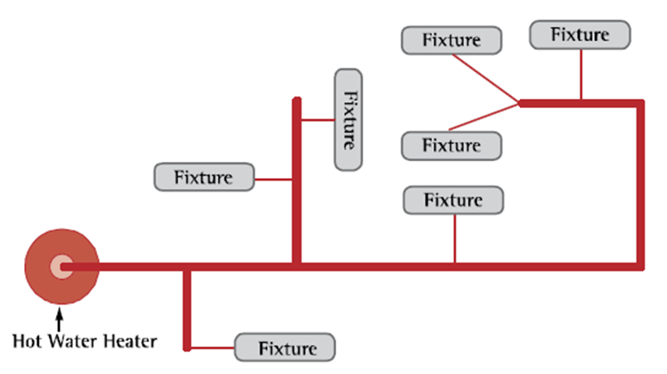

Figure 1. A General Configuration Typical of Trunk and Branch Systems

Trunk and branch systems are the most common type of hot water delivery system. They can be utilized in both single- and multi-family homes. In terms of maximizing hot water delivery system efficiency, trunk and branch systems are most suitable for smaller homes, homes with relatively few fixtures, or in multi-family housing if installed individually in each unit. It may be difficult to design an efficient trunk and branch system in larger homes with spacious layouts and a large number of fixtures. Trunk and branch systems have the greatest potential to be inefficient, if care is not taken to centralize fixture placement and minimize pipe run lengths.

Core Systems

Core systems are a particular type of trunk and branch system. They are, by design, generally more efficient than a traditional trunk and branch system. Core systems utilize a central plumbing core, where plumbing areas (i.e., kitchens, bathrooms, laundry rooms) are placed in close proximity to the water heater. Hot water is piped directly to each fixture or group of fixtures using smaller diameter piping when appropriate and as direct a path as possible. Figure 2 illustrates the main design principles of this configuration. As the figure shows, the relative proximity of the fixtures and direct horizontal runs minimizes the length of piping and the amount of time required for hot water to reach each fixture.

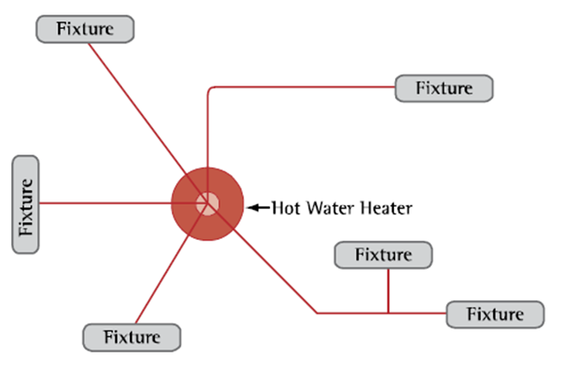
Figure 2. A General Configuration Typical of Core Systems

Because core systems use less—and smaller diameter—piping, they can significantly reduce conductive heat loss and the amount of water that users waste waiting for hot water to arrive at the fixtures. They can also be made with any type of piping (or multiple types if necessary); copper, CPVC, and cross-lined polyethylene (PEX) are the most commonly used types. As a result, core systems provide greater flexibility and can be less expensive and quicker to install relative to other system types.

Core systems can be utilized in both single- and multi-family homes. They are similar to trunk and branch systems in that they are most suitable for smaller homes or homes with relatively few fixtures. They might not be suitable for multi-family buildings if used as a building-wide hot water delivery system. It is also important to note that since core systems supply each fixture or point of use with their own line, they can be difficult to retrofit at a later time.

Whole-House Manifold Systems

Whole-house manifold systems, also called parallel pipe or home run systems, use small diameter, flexible piping (such as PEX) that run directly to each individual fixture from a central manifold. As shown in Figure 3, the central manifold is typically kept in close proximity to the water heater. The manifold may be constructed of either plastic or metal.

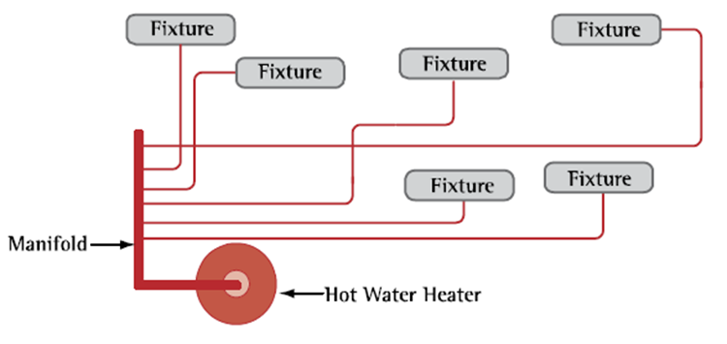
Figure 3. A General Configuration Typical of Whole-House Manifold Systems

The use of flexible piping allows these systems to be installed more quickly than rigid, non- flexible plumbing systems because fewer fittings are necessary during installation. Because the flexible piping is supplied as spools of continuous piping, plumbers can lay out relatively long piping runs without needing to install coupling fittings at regular intervals. Furthermore, by virtue of the piping’s flexibility, it can be redirected as needed using continuous sweeping turns, eliminating the need for elbow fittings, which are time-consuming to install and contribute to the loss of pressure and heat as water moves through the system.

Whole-house manifold systems also equalize pressure, and, therefore, several fixtures can be used simultaneously without dramatic changes in pressure or temperature. As noted above, the elimination of inline fittings also reduces pressure losses, allowing for the use of smaller 3/8 inch diameter piping. Reduced pipe diameters in turn deliver hot water to fixtures faster and with less water and energy waste than conventional piping systems.

Whole-house manifold systems can be utilized in either single- or multi-family homes. This system type is an ideal option for larger homes with more spacious layouts and multiple fixtures in which longer piping runs may be necessary. Like core systems, whole-house manifold systems supply each fixture with an independent line and can be difficult to retrofit.

Demand-Initiated Recirculation Systems

Recirculation systems consist of one continuous hot water supply loop that recirculates water throughout the home. As shown in Figure 4, a circulating pump draws hot water through the recirculation loop and returns to the water heater any ambient-temperature water residing within the loop. Alternately, the pump may return this water to the cold water line while simultaneously drawing hot water from the water heater. Utilizing the cold water line as the return is often a convenient solutions for inefficient distribution systems that are being retrofitted. Recirculation systems save water both because they can reduce the wait time for hot water to nearly nothing (thus eliminating the loss of water down the drain) and by returning ambient-temperature water stored in the piping back to the heater. This decreases the work that a water heater must do to reach an acceptable temperature. In addition, the recirculation loop is typically located where it can be kept as short as possible and within 10 feet of every fixture.
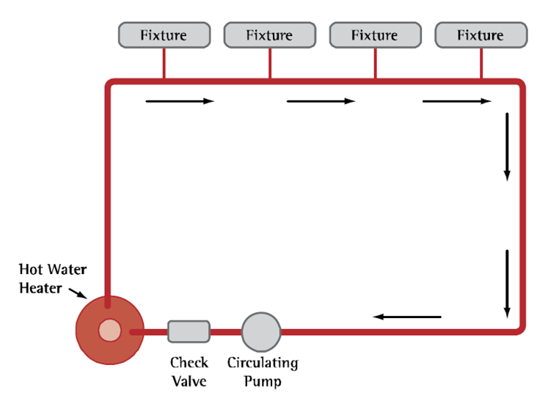
Figure 4. A General Configuration Typical of Demand-Initiated Recirculation Systems

Demand-initiated recirculation systems have been found to be more energy-efficient than other timer- or temperature-based recirculation systems, because hot water is only drawn into the recirculation loop when hot water is needed. Demand-initiated systems use sensor electronics installed at the fixtures to automatically adjust standing ambient temperatures in the hot water recirculation loop. When the user activates the pump by pushing a button, or via a motion sensor located near the hot-water fixture, the sensor measures temperature changes in the recirculation loop and activates the circulating pump until the water in the loop reaches a specified temperature, at which time the water is delivered to the fixture.

It is important to note that timer- and temperature-based recirculation systems may not be used to meet WaterSense® new home specification criteria. Research indicates that these systems can use a large amount of energy to maintain the water temperature in the recirculation loop and are considered to be energy-inefficient.

Demand-initiated recirculation systems may offer builders more flexibility than the other types of systems because they can allow for longer pipe runs and less centralized fixture placement. Although demand-initiated recirculation systems use energy in their operation, they can save energy in three ways:

- The water in the recirculation loop that is returned to the water heater is generally warmer than water coming into the house, and therefore, the water heater requires less energy to keep the water heated.
- Since hot water is distributed at a high flow rate to fixtures, significantly less heat is lost during distribution.
- The high distribution flow rate also allows hot water to reach the fixtures faster, and therefore, less hot water is needed to prime the recirculation loop.

While the cost of the pump and wiring of the required sensors represent incremental costs, recirculation systems can be quicker to install and utilize less pipe than traditional distribution systems, which in turn can reduce installation costs.

Due to the energy required to recirculate the ambient-temperature water stored in the system, demand-initiated recirculation systems may not be suitable for larger homes, where large loops are necessary or where it is not practical to locate fixtures within ten feet of the loop. So while builders should weigh the water efficiency benefits against the potential energy-related drawbacks associated with the use of this type of system in large homes, the energy saved by reducing the amount of water that is heated and then run down the drain typically far outweighs the energy used to operate the pump.

