NATURAL VENTILATION AND COOLING
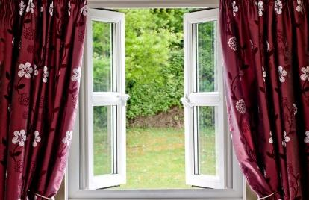 | WHAT?  Fresh air cooling, also known as night flushing or natural ventilation, uses night-time air to cool a home and all of its thermal mass. Often this will keep a home cool through much of the next day. Natural ventilation works best in climates with cool nights and regular breezes.
WHY?
Natural ventilation relies on the wind and the “chimney effect”: air enters the home through lower windows where it absorbs heat; through convection, the air rises and exits through windows upstairs. In some climates, using natural ventilation for cooling can significantly cut cooling energy costs or even eliminate the need for air conditioners.
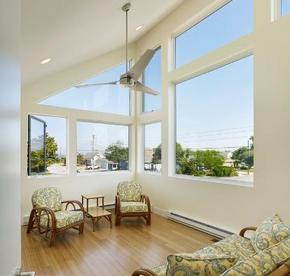 | HOW?  Operable window openings –designed to optimize– cross-ventilate with prevailing cooling breezes, and/or fans can be used to draw in cool outside air and distribute it throughout a home.  Where fans are used, temperature and humidity sensors can help ensure only cool, dry air is drawn in.  Filters can be used to remove dust and pollen; however, natural ventilation should not be used when outdoor air quality is poor.  Landscaping also can be used to enhance or hinder natural ventilation.

