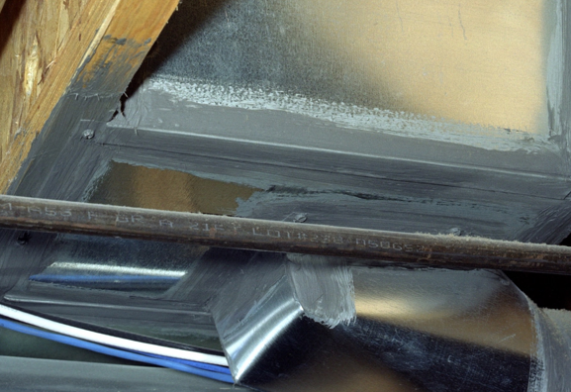 | WHAT?  A properly sealed heating and cooling duct system can:  - Reduce utility bills by up to 20%  - Increase comfort throughout the home  - Improve IAQ by reducing moisture, dust, and pollen
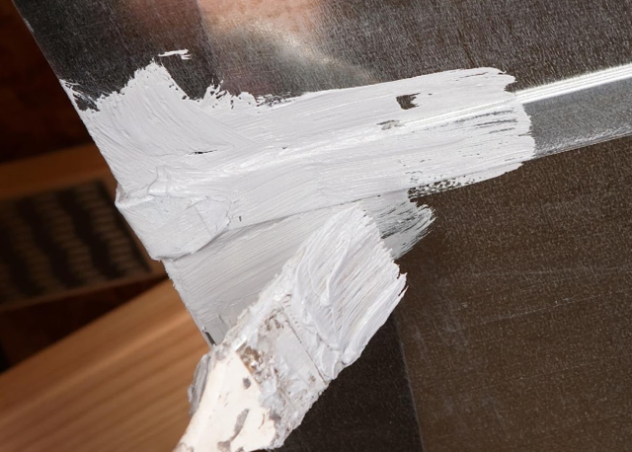 | WHY?  As conditioned air escapes ducts supplying heating and cooling, occupants need to run systems longer to create a comfortable living space.  Poorly sealed return ducts in unconditioned spaces can potentially draw in contaminated air and spread contaminants throughout the house.
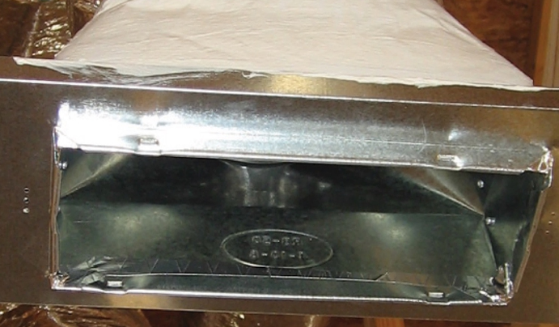 | HOW?  - All duct leaks, connections, and plenums shall be sealed with UL-approved mastic, UL 181 tape, or equivalent.  - For additional strength with seams that are wider than 1/8 inch, cover the gap with fiberglass mesh tape, then apply the mastic.  - Regular cloth-backed duct tape should not be used because it can dry out and fail quickly.
MORE ABOUT TIGHT DUCT SEALING

