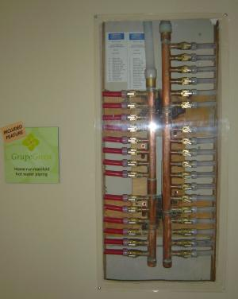 | WHAT?  An efficient alternative to a traditional trunk-and-branch plumbing layout is a central manifold distribution system using plastic piping to route all hot and cold water lines directly to each fixture or appliance from a central manifold connected to the water heater.
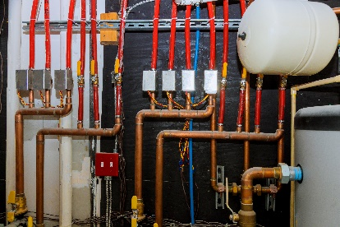 | WHY?  This method allows for every appliance in a building to be connected from manifold to appliance or manifold to fixture via continuous loops. Each appliance or fixture has its own circuit of pipework, and if that is faulty, its circuit can simply be turned off and that single item can be isolated in the event of a problem.
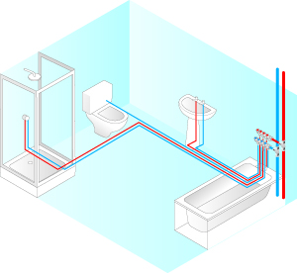 | HOW?  With manifold plumbing, pipes can be adjusted and tailored to individual appliances. Fewer joints in the system mean a lot fewer leaks, and there are no joints under floorboards or inside walls—the only connections are at the appliance and at the manifold. Because of the need for fewer joints, installation and maintenance times are faster. This method means a safer and improved way to control a building’s plumbing.
MANIFOLDS: MANIFOLD PLUMBING

