LOW-VOC CARPET AND PADS
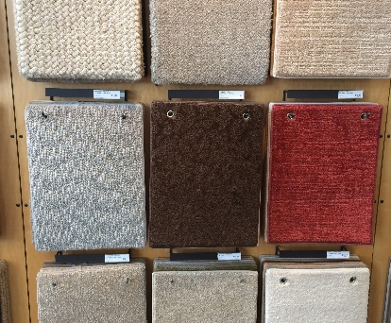 | WHAT?  Certified low-VOC and no-VOC carpets and carpet pads contribute to a new home’s healthy indoor environment. (VOCs are volatile organic compounds.)
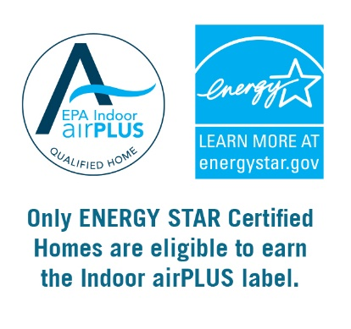 | WHY?  Carpet, carpet pads, and carpet adhesives can contain volatile organic compounds (VOCs) and other chemicals that have short- and long-term adverse health effects, which can include varying degrees of eye, nose, and throat irritation; headaches; loss of coordination and nausea; allergic skin reactions; and even damage to the liver, kidneys, and central nervous system.  Installing certified products lowers risk of occupant exposure to high levels of VOCs from construction materials.
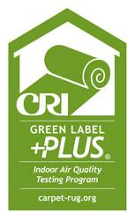 | HOW?  For living spaces, select third-party-certified low-emission carpet products designed to reduce human exposure indoors to individual VOCs. Indoor airPLUS provides guidance on identifying compliant products, including industry databases and examples of product labeling.  Indoor airPLUS specifies that, at a minimum, 90% of the home’s interior surface area covered by carpet and carpet adhesives must use products labeled with the Carpet and Rug Institute (CRI) Green Label Plus testing program criteria. The carpet cushion, or padding, should be CRI Green Label Plus-certified.

