BSESC—Lighting, Appliances, and Miscellaneous Loads

Proficiency Level 2. Understand

Learning Objective 2.1
Describe ways to reduce plug load and appliance loads in building systems.

Lecture Notes
Plug loads and appliance loads may contribute significantly to the energy consumption of a building. Because the end-users and occupants make decisions about operation and replacement, one of the best ways to reduce plug loads and appliance loads in buildings is through education and technology that help make the total amount and cost of energy used visible.
- Educate consumers and occupants about the contribution of plug loads and appliance loads. This includes notification to end-users, signage, and greater awareness.
- Install smart electronics in key areas to enhance energy efficiency.
- Consider incentive programs when reasonable to encourage new behavior.
To address parasitic plug loads, advanced power strips may be appropriate. These power strips offer the same advantages of normal power strips, like surge protection, but they also have the ability to detect and remove parasitic plug loads. Power strips with small motion-activated sensors are also relatively inexpensive, and they offer the ability to easily turn a monitor and printer off when the occupant is out of the room. Most of these devices range in cost from $19–70 (Earle & Sparn 2012). More detail about the type of advanced power strip to consider is available on the U.S. Department of Energy’s (DOE’s) Building America Solution Center (BASC) in the “Smart Power Strips” guide.
For plug load efficiency more broadly, the use of smart plug devices offers many benefits to consumers. Devices offer the ability to easily set on/off schedules and timers, and provide random on times for security. These products are well aligned with voice activated central smart home hubs like Google Home and Amazon Alexa. Product lines include Belkin’s Wemo and Samsung SmartThings. Some products are installed at the wall outlet plug, but others may be installed or replaced as light switches. For example, it is relatively easy to install a smart switch for a bathroom fan. The smart home app may be used to control the bathroom fan timers, so a fan will only run for 20 minutes and then shut off automatically. A smart outlet plug for a lamp in the living room may be used for voice activation, and a timer for auto-off at 10 pm.
Appliances loads are more challenging to address since certain appliances must be operated in a specific way throughout the course of their operating life (typically 10–15 years). It is important to work closely with builders and occupants to install high-efficiency appliances at the time of construction. Whenever possible, look for EnergySTAR® product labeling for appliances and specify the highest energy efficiency reasonable for the home. Often, rebates or incentive programs may be available from local utilities and state governments to help fund these items (see the DSIRE database for possible incentives in your area).
Take time to educate everyone about important energy features on common appliances:
- Dishwashers – Use the air dry feature and delayed start to help shift energy demand in time to help the utilities operate more efficiently.
- Washing Machines – Select the coldest water temperature reasonable for your laundry. The cold-water settings significantly reduce the energy needed for water heating.
- Dryers – Select the lowest drying temperature reasonable for your laundry. It helps protect fabrics and improve energy performance.
- Refrigerators – Turn your refrigerator temperature to 35–58°F.

References
Earle L and B Sparn. 2012. Results of Laboratory Testing of Advanced Power Strips. https://doi.org/10.2172/1219753.

Learning Objective 2.2
- Explain the benefits of smart appliances and how they interact with the grid.

Lecture Notes
All plug loads, appliance loads, and miscellaneous electric loads are of particular interest in modern building design because of the possible interactions with the electricity grid. The smart grid is the two-way interaction of devices with the larger electricity grid. Smart grid communication will allow future appliances and plug loads to work with the utilities and grid demand to manage our electricity infrastructure. This interaction is important because grid events occur very quickly, giving utility operators a small time window to make adjustments.
Smart grid appliances are the future of energy efficiency in many homes; these technologies will help mitigate peak load issues and optimize grid response to sudden events. To facilitate this efficiency, small chips have been designed to work directly with consumer appliances. The controller in the appliance can adjust some elements of operation to reduce appliance energy loads in real time. For example, the smart grid dryer would be able to reduce the temperature of the dryer for a few minutes, allowing the energy load to drop temporarily. This has no impact on the consumer or the total operation of the appliance, but it allows the greater energy infrastructure to save money and optimize energy use. If every home in the country did the same, the dryers could be used as a cushion to stabilize grid events (e.g., an unexpected power outage).
Consumers may be incentivized to use this type of feature in an appliance with a small compensation (e.g., see the PowerMinder program offered by the Sacramento Municipal Utility District). In the long run, this type of feature could be used to optimize the delayed start of a washing machine to the lowest energy demand overnight when power is cheapest for the consumer. This type of two-way communication will also support integration of renewable energy in the future, as it allows appliances to adjust around time-of-day events caused by high solar energy production.
The smart grid thermostats are one of the best early examples of this type of device. Many utilities have partnered with Google (Nest), Ecobee, and other smart thermostat manufacturers to offer small cash incentives if consumers enroll in demand control of devices, allowing a delayed reaction on peak heating or cooling days. For utilities, the benefits are significant, preventing the construction of new power plants in some cases. An example is the PGE program in Oregon, with details about consumer incentives and how the program operates.

Learning Objective 2.3
- Summarize the health and energy benefits of enhanced lighting systems.

Lecture Notes
Lighting is an important feature of a building for occupants. Many studies have found that people are more productive under optimal lighting level conditions (Boyce et al. 2000; Küller et al. 2006; Veitch and Newsham 1998). The biological effects of lighting choices are an active area of research (Pauley 2004; van Bommel 2006). The research shows that it is important to get the lighting “right,” but we also need to consider the energy efficiency for lighting systems.
The health benefits of enhanced lighting are significant. Too much light at the wrong time of day can shift physiological processes. This has an impact on sleep/wake cycles that influence many facets of human health. A recent study in Nature explores the effect of light on the astronauts at the International Space Station (Katsnelson 2019). Using LEDs and enhanced lighting technology, the research team is working to provide blue light when alertness is required, while reducing the light levels in the evening to accommodate proper sleep schedules.
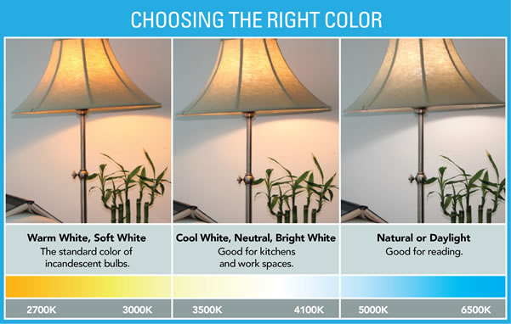
One key aspect of light health in LED is color temperature, the measurement of color rendition in lights. Light color is measured on a temperature scale using Kelvin (K) units. Energy-efficient lighting products are available today in a variety of color renditions, ranging from lower Kelvin (<3000K) “warm” yellowish lights to higher Kelvin (>5000K) cool white lights. For comparison, daylight is typically identified as 4500K or higher (DOE 2017).
Figure 1. Examples of lighting color-temperature (DOE 2017)
- For a warmer light, look for bulbs marked 2700-3000K.
- For a whiter light, look for bulbs marked 3500-4100K.
- For cooler white light, look for bulbs marked 5000-6500K.
Early innovation in LED technology was driven in part by the DOE L-Prize competition. The product evolution has been dramatic over time, providing energy efficiency and long life, but also features that tie to smart homes and provide consumers with new flexibility in lighting applications. The Phillips Hue products are one example of an innovative way that consumers may choose the specific color temperature for a room using a remote or smartphone link.
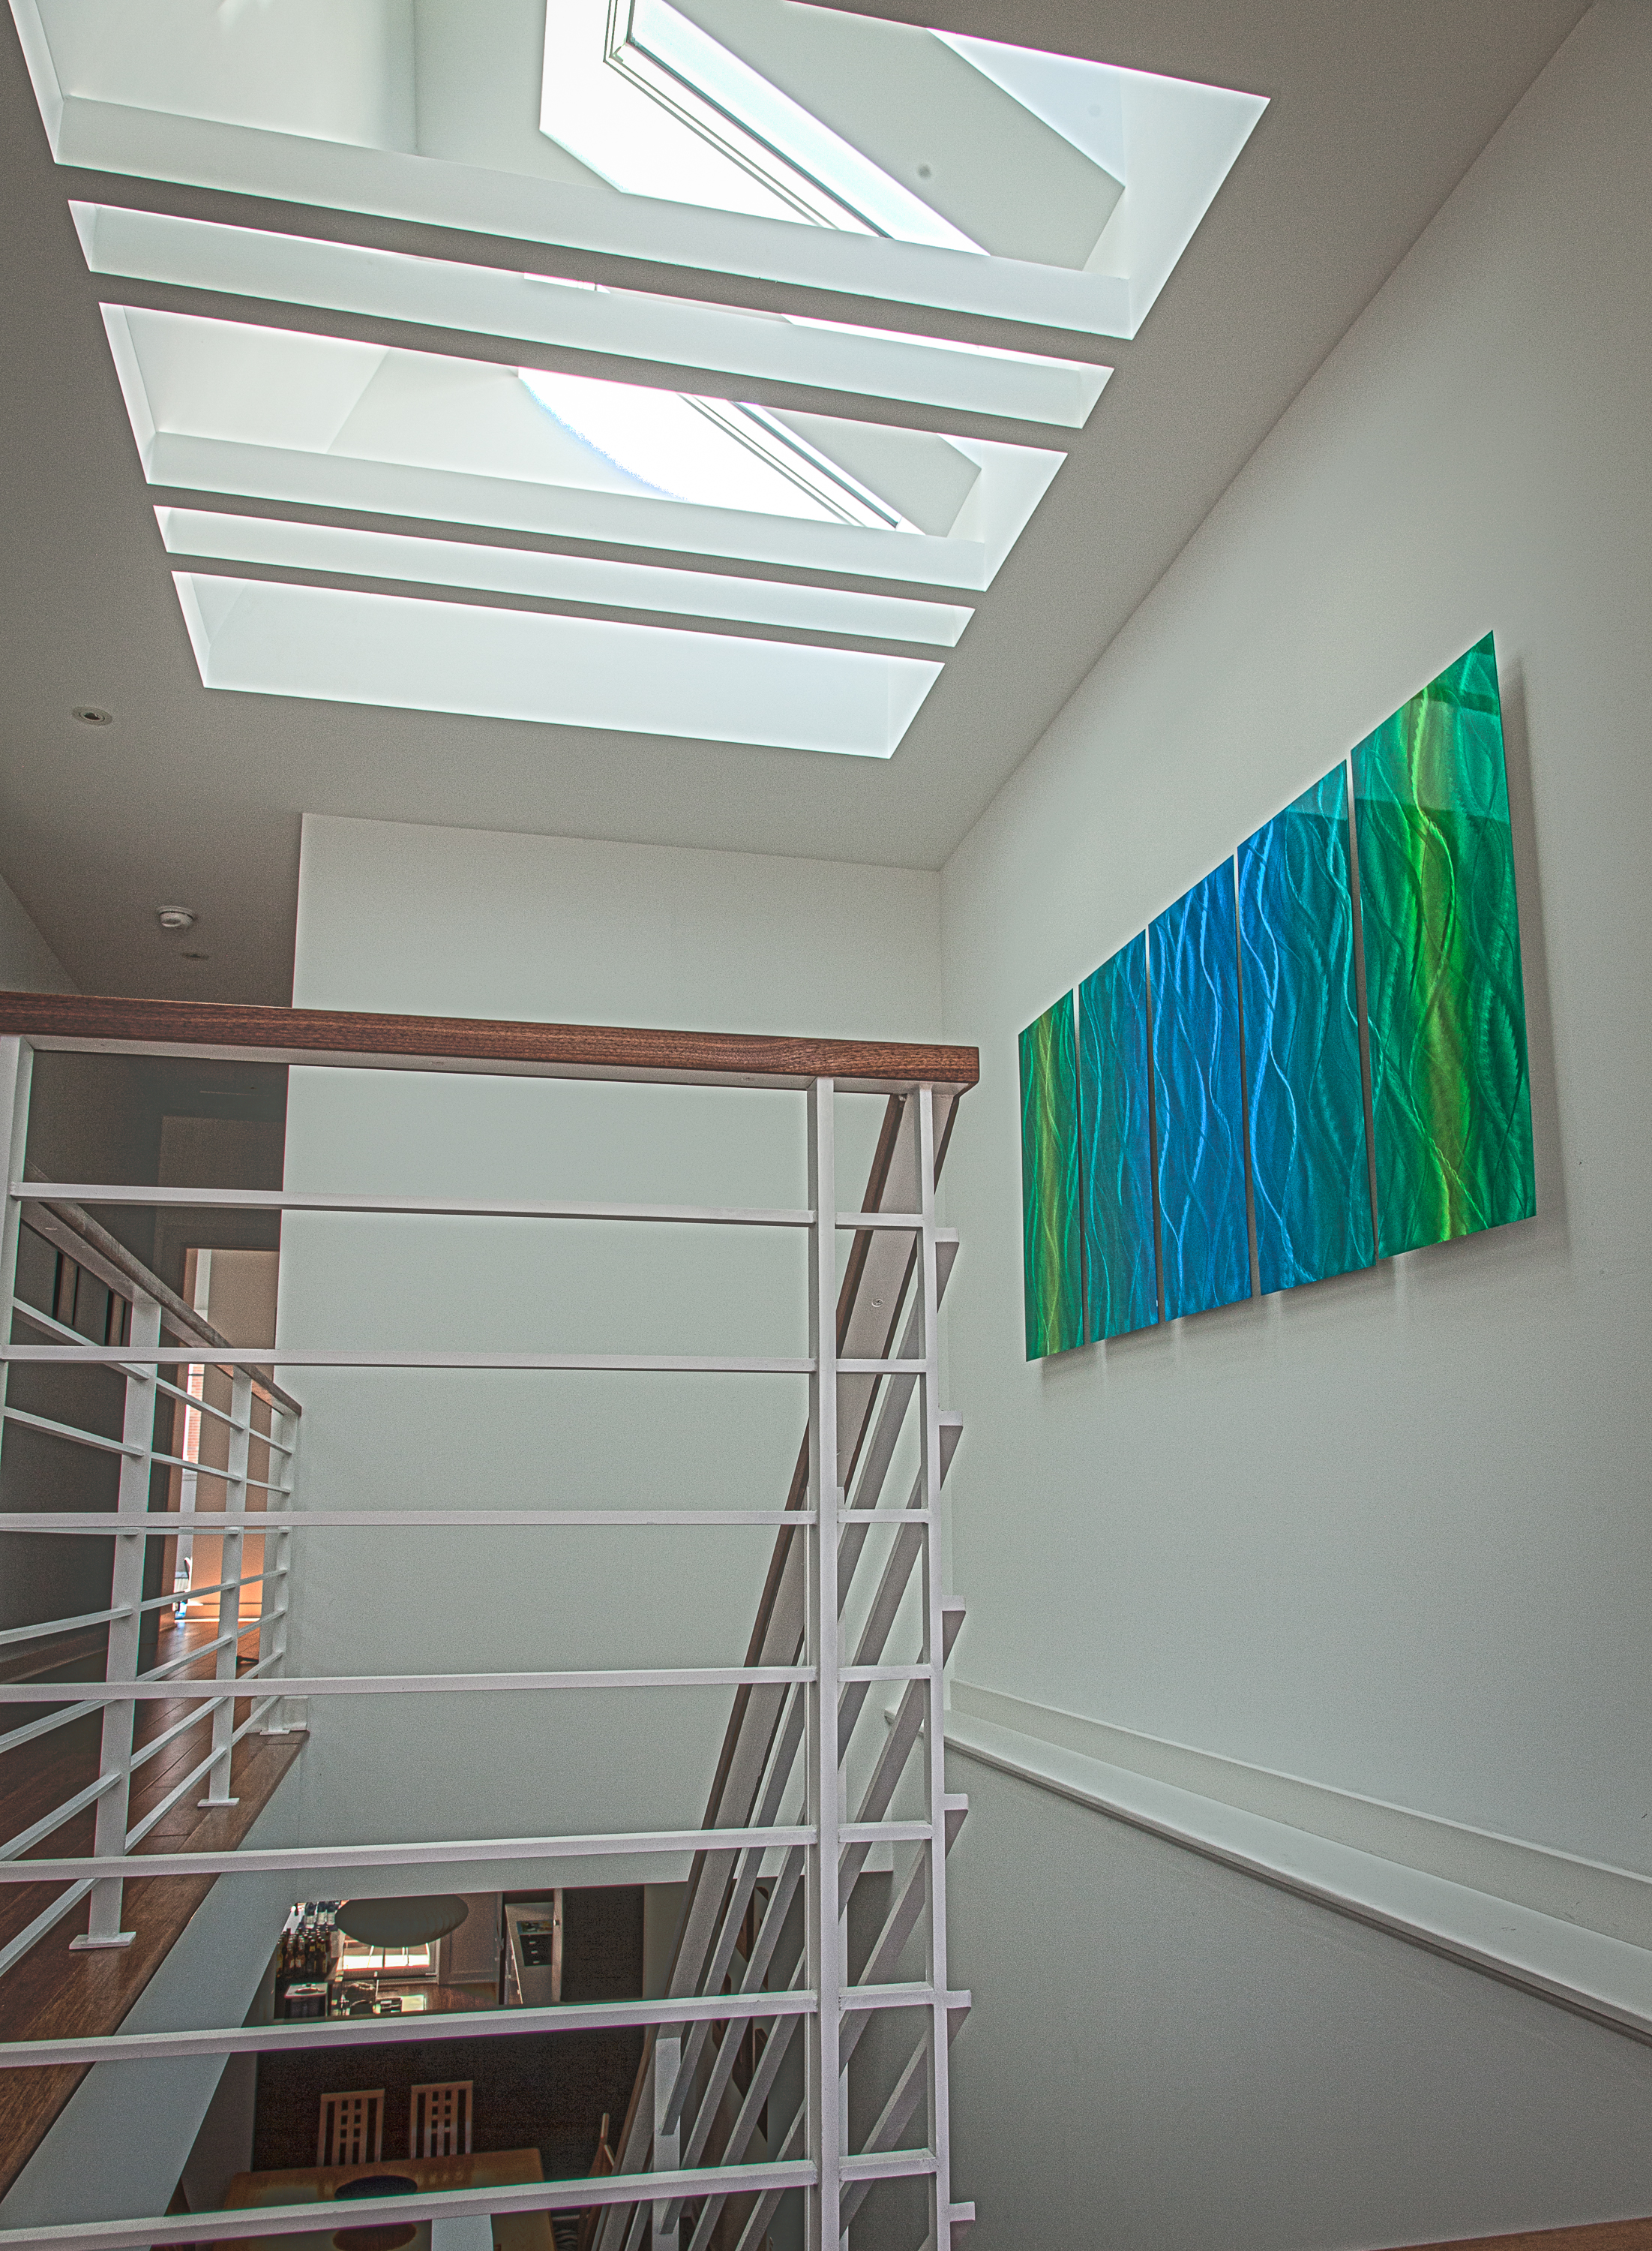
Figure 2. Skylights can bring natural daylight to interior spaces
It is important to consider natural light, or daylighting, in homes in addition to optimizing the lighting products. Design of a home that allows significant natural light will increase the value to consumers and make the occupants healthier. Daylighting in homes may be achieved using skylights, light tubes, or interior windows.

References
Boyce PR, NH Eklund, and SN Simpson. 2000. Individual lighting control: Task performance, mood, and illuminance. Journal of the Illuminating Engineering Society. 29(1):131–142. https://doi.org/10.1080/00994480.2000.10748488.
Katsnelson A. 2019. Lighting design for better health and well being. Nature. https://doi.org/10.1038/d41586-019-01113-w.
Küller R, S Ballal, T Laike, B Mikellides, and G Tonello. 2006. The impact of light and colour on psychological mood: A cross-cultural study of indoor work environments. Ergonomics. 49(14):1496–1507. https://doi.org/10.1080/00140130600858142.
Pauley SM. 2004. Lighting for the human circadian clock: Recent research indicates that lighting has become a public health issue. Medical Hypotheses. 63(4):588–596. https://doi.org/10.1016/j.mehy.2004.03.020.
U.S. Department of Energy (DOE). 2017. High-Efficiency Lighting. A guide prepared by Pacific Northwest National Laboratory for the DOE Building Americal Solution Center. https://basc.pnnl.gov/resource-guides/high-efficacy-lighting#quicktabs-guides=1
van Bommel WJM. 2006. Non-visual biological effect of lighting and the practical meaning for lighting for work. Applied Ergonomics. 37(4 SPEC. ISS.):461–466. https://doi.org/10.1016/j.apergo.2006.04.009.
Veitch JA and GR Newsham. 1998. Lighting quality and energy-efficiency effects on task performance, mood, health, satisfaction, and comfort. Journal of the Illuminating Engineering Society. 27(1):107–129. https://doi.org/10.1080/00994480.1998.10748216.

