BSESC—Lighting, Appliances, and Miscellaneous Loads

# Proficiency Level 1. Remember

## Learning Objective 1.1

Define incandescent, compact fluorescent lamps (CFL), light-emitting diode (LED), and lighting power density in the context of building energy systems.

### Lecture Notes

Lighting is an important feature of a building for occupants. Many studies have found that people increase productivity when lighting levels are optimized (Boyce, Eklund, and Simpson 2000; Küller et al. 2006; Veitch and Newsham 1998). The biological effects of lighting choices are an active area of research (Pauley 2004; van Bommel 2006). The research shows that it is important to get the lighting “right,” but we also need to consider the energy efficiency for lighting systems.

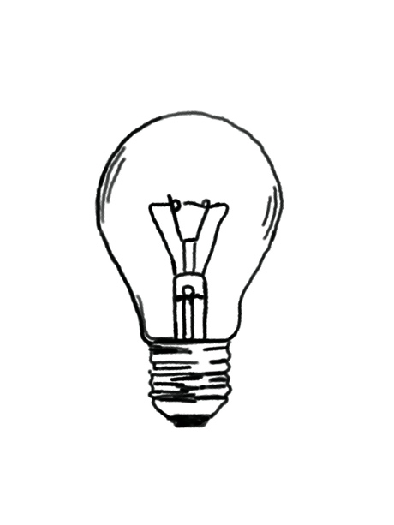

Figure . Traditional incandescent style A-19 lighting product

Energy efficiency in lighting systems has a long and interesting history. The first type of indoor lighting was a candle or oil lamp carried around the home as someone used it. Gas lighting became common over time, but all these early lighting technologies had significant safety issues (fire, smoke, etc.) (Jones 2014). The invention of the electric light in the late 1800s was a technological leap forward. Traditional incandescent lighting included a wire filament that was heated with electric current until it glowed. Because incandescent lighting relies on heat from a wire, most of the energy is converted to heat; only about 5-10% is converted to light. Incandescent products for residential use were typically rated at 60 watts (W) or 100 W.

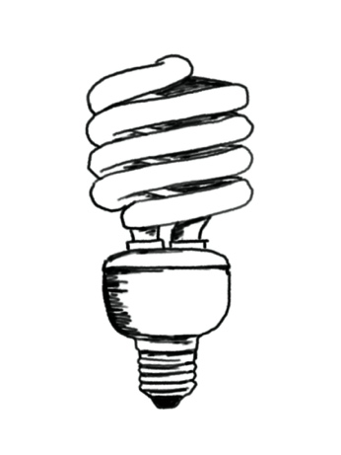

Figure . Typical CFL lighting product showing the curved fluorescent tubes

The A-19 lighting products are classified based on the shape of the product (A) and the diameter (19 eighths). In residential buildings, most have an Edison screw base to standardize the connection. The A-19 style is the classic style for consumer replacements because historical fixtures have been designed for this size and connection in many homes. Other lighting classifications are commonly found in homes as well.

Fluorescent lighting gained popularity in the 1990s as a more energy efficient option. [Compact Fluorescent Lamps](https://en.wikipedia.org/wiki/Compact_fluorescent_lamp#:~:text=A%20compact%20fluorescent%20lamp%20(CFL,fixtures%20designed%20for%20incandescent%20bulbs.) (CFLs) were designed to replace a traditional incandescent in a lamp or fixture for residential applications. CFLs were distinct in the way the fluorescent tube was shaped to allow replacement in existing fixtures. CFL products often had different color temperature performance, creating a light quality that consumers did not enjoy as much as incandescent products. The energy efficiency of CFLs is much better than incandescent, with a standard replacement energy rating of 13–30 W for the same lighting level as a 60 or 100 W incandescent.

The [Light Emitting Diode](https://en.wikipedia.org/wiki/Light-emitting_diode) (LED) products became cost effective in the early 2000s. Light is converted from electricity as current flows through a semiconductor. The products are more energy efficient than CFLs, often 8–15 W to replace a 60 W or 100 W incandescent. The LED lamps are rated for much longer life, making them more cost effective. LEDs do still generate heat (Storey et al. 2016), and early products had visible heat exchangers to help protect the sensitive LED electronics. Most recent LED products have less visible heat exchangers due to improved LED efficiency, but the products are still significantly more complex than incandescent lighting.

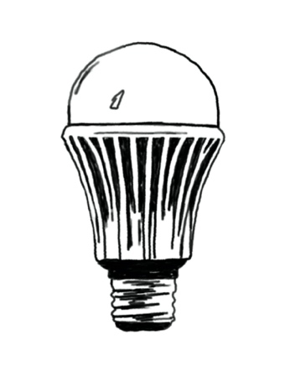

Figure . Typical LED lighting with a metal heat exchanger at the base

The U.S. Department of Energy (DOE) predicts that LED lighting could have a great impact on energy efficiency: “By 2027, widespread use of LEDs could save about 348 TWh (compared to no LED use) of electricity: This is the equivalent annual electrical output of 44 large electric power plants (1000 megawatts each), and a total savings of more than $30 billion at today's electricity prices” (DOE 2020).

Early innovation in LED technology was driven in part by the [DOE L-Prize competition](https://www.laserfocusworld.com/test-measurement/research/article/16562143/philips-grabs-first-10m-doe-l-prize-with-led-bulb). The product evolution has been dramatic over time, providing energy efficiency and long life, but also features that tie to smart homes and provide consumers with new flexibility lighting applications. The [Phillips Hue product](https://www.philips-hue.com/en-us)s are one example of an innovative way that consumers may choose the specific color temperature for a room using a remote or smartphone link.

Table 1 compares a 60-W traditional incandescent with energy efficient bulbs that provide similar light levels (table adapted from DOE 2020).

Table 1. Comparisons between a traditional incandescent, halogen incandescent, CFL, and LED

|  |  |  |  |  |  |  |
| --- | --- | --- | --- | --- | --- | --- |
|  | **60W Traditional Incandescent** | **43W Energy-Saving Incandescent** | **15W CFL** | | **12W LED** | |
| **60W Traditional** | **43W Halogen** | **60W Traditional** | **43W Halogen** |
| **Energy $ Saved (%)** | – | ~25% | ~75% | ~65% | ~75%-80% | ~72% |
| **Annual Energy Cost\*** | $4.80 | $3.50 | $1.20 | | $1.00 | |
| **Bulb Life** | 1000 hours | 1000 to 3000 hours | 10,000 hours | | 25,000 hours | |
| *Based on 2 hrs/day of usage, an electricity rate of 11 cents per kilowatt-hour, shown in U.S. dollars. | | | | | | |

The energy efficiency community has used **Lighting Power Density (LPD)** as one method to quantify the energy efficiency for lighting in a specific space. LPD is a good method for capturing the energy efficiency because it allows all types of lighting to be evaluated across a specific space. To calculate the LPD, you need to determine the size of the room (area) and the total energy in lighting.

$$LPD= \frac{\sum{lighting energy}}{Area}$$

**Lumens** are the unit used to characterize how much light you get from a specific lighting product. A light that has more lumens is a brighter light. The brightness, or lumen levels, of the lights in your home may vary widely, so here is a [rule of thumb from DOE](https://www.energy.gov/energysaver/save-electricity-and-fuel/lighting-choices-save-you-money/lumens-and-lighting-facts):

* To replace a 100-W incandescent bulb, look for a bulb that gives you *about* 1600 lumens. If you want something dimmer, go for less lumens; if you prefer brighter light, look for more lumens.
* Replace a 75-W bulb with an energy-saving bulb that gives you about 1100 lumens.
* Replace a 60-W bulb with an energy-saving bulb that gives you about 800 lumens.
* Replace a 40-W bulb with an energy-saving bulb that gives you about 450 lumens.

You can use the [ENERGY STAR Product Finder](https://www.energystar.gov/productfinder/product/certified-light-bulbs/results) to find ENERGY STAR certified light bulbs and fixtures that meet the household’s needs.

Another way lighting efficiency is measured is to divide the lumens the bulb produces by its energy input, resulting in an efficiency measure of lumens per watt.

In summary, light bulbs keep improving in efficiency and quality, and the future looks bright!

Figure 4. LED Light bulbs keep improving in efficiency (EIA 2014)

### References

Boyce PR, NH Eklund, and SN Simpson. 2000. Individual lighting control: Task performance, mood, and illuminance. *Journal of the Illuminating Engineering Society.* *29*(1):131–142. <https://doi.org/10.1080/00994480.2000.10748488>.

Jones CF. 2014. *Routes of Power: Energy and Modern America*. Harvard University Press: Cambridge, MA

Küller R, S Ballal, T Laike, B Mikellides, and G Tonello. 2006. The impact of light and colour on psychological mood: A cross-cultural study of indoor work environments. *Ergonomics.* *49*(14):1496–1507. <https://doi.org/10.1080/00140130600858142>.

Pauley SM. 2004. Lighting for the human circadian clock: Recent research indicates that lighting has become a public health issue. *Medical Hypotheses.* *63*(4):588–596. <https://doi.org/10.1016/j.mehy.2004.03.020>.

Storey T, R Rackerby, H Dillon, and L Gingerich. 2016. Thermal Performance of Domestic Replacement A19 LED Lighting Products. *Volume 14: Emerging Technologies; Materials: Genetics to Structures; Safety Engineering and Risk Analysis*, V014T07A015. <https://doi.org/10.1115/IMECE2016-67974>.

U.S. Department of Energy (DOE). 2020. *LED Lighting*. Retrieved August 10, 2020, from the DOE website. <https://www.energy.gov/energysaver/save-electricity-and-fuel/lighting-choices-save-you-money/led-lighting?__utma=1.1029851002.1596315434.1597080709.1597080709.1&__utmb=1.3.10.1597080709&__utmc=1&__utmx=-&__utmz=1.1597080709.1.1.utmcsr%3Dgoogle%7Cutmccn%3D>

U.S. Energy Information Administration (EIA). 2014. Today in Energy. Retrieved September 24, 2020, from the EIA website. <https://www.eia.gov/todayinenergy/detail.php?id=18671>

van Bommel WJM. 2006. Non-visual biological effect of lighting and the practical meaning for lighting for work. *Applied Ergonomics.* *37*(4 SPEC. ISS.):461–466. <https://doi.org/10.1016/j.apergo.2006.04.009>.

Veitch JA and GR Newsham. 1998. Lighting quality and energy-efficiency effects on task performance, mood, health, satisfaction, and comfort. *Journal of the Illuminating Engineering Society.* *27*(1):107–129. <https://doi.org/10.1080/00994480.1998.10748216>.

## Learning Objective 1.2

Define plug load, miscellaneous loads, smart grid, and parasitic load in the context of building energy systems.

### Lecture Notes

In buildings, small electrical appliances add up! Often called **miscellaneous electric loads (MELs)**, the small phones, computers, toasters, and blenders that we plug in to the wall may be up to 10% of a home’s energy use. The building science community often refers to these loads as **plug loads**. The plug loads are anything a consumer might plug into a wall outlet, but because appliances are changed more frequently than other features of a building, they are trickier for managing energy efficiency.

When managing consumer plug loads, it is important to consider parasitic loads. **Parasitic plug loads** (or vampire loads) are devices that continue to draw small amounts of power even when the device is turned off. An example of a parasitic load might be a printer. Even when you are not using the printer it may be powering the display and checking for incoming requests over the network. These small tasks continue to consume small amounts of power. Computers often have a low power mode or standby mode that may have a surprisingly high parasitic load.

MELs are typically considered separately from **appliance loads** in residential buildings. Appliance loads are associated with larger equipment in a home, including the refrigerator, washing machine, dryer, and dishwasher. This distinction is because engineers and designers typically have accurate estimates for appliance loads. For example, most homes only have one refrigerator and dryer. The [EnergySTAR® program](https://www.energystar.gov/products/appliances) has been an important way for consumers to understand the efficiency of most major appliance for many years. High-[efficiency washing machines](https://www.energystar.gov/products/appliances/clothes_washers) have become very cost effective for lower energy and water use, and high-performance [refrigerators](https://www.energystar.gov/products/appliances/refrigerators) are now common.

Figure . Infographic about parasitic plug loads (NREL 2013)

All plug loads, appliance loads, and MELs are of particular interest in modern building design because of the possible interactions with the electricity grid. The **smart grid** is the two-way interaction of devices with the larger electricity grid. Smart grid communication will allow future appliances and plug loads to work with the utilities and grid demand to manage our electricity infrastructure, shifting power demand as needed to better integrate renewable energy, respond to unexpected power losses, and be more resilient to extreme natural events.

### References

National Renewable Energy Laboratory (NREL) 2013. Saving Energy Through Advanced Power Strips. Infographic NREL/PO-5500-60461, prepared by NREL for the U.S. Department of Energy (DOE). Retrieved September 24, 2020, at <https://www.nrel.gov/docs/fy14osti/60461.pdf>.