BSESC—Life-Cycle Analysis

# Proficiency Level 3. Apply

## Learning Objective 3.1

Interpret the results from a simple life-cycle assessment and use the data to make recommendations about a building system.

### Lecture Notes

The interpretation step of the life-cycle analysis (LCA) process includes an uncertainty analysis, a sensitivity analysis, and an analysis of the results. The results of an LCA can be complex, and because the units of each environmental or cost impact may vary, it can be useful to consider specific tools for interpreting the results.

The first step in the interpretation is often an output table based on the calculation of matrix [g]. An example of this type of table is shown in Table 1. In this example, each lighting product analyzed was shown as a different column. Each row is based on the original units and impact categories from the inventory analysis (matrix [B]). The values represent the total environmental impact for all the processes we defined, including transportation, manufacture, use, and end of life.

Table 1. Example of the results summary table based on matrix [g] for several lighting products (Dillon, Ross, and Dzombak 2019)

|  |  |  |  |  |  |
| --- | --- | --- | --- | --- | --- |
| **Impact Category** | **Units** | **Product 0** | **Product 1** | **Product 2** | **Product 3** |
| Abiotic resource depletion | Kg Sb-Eq | 3.03E-3 | 2.17E-3 | 1.33E-3 | 1.42E-3 |
| Global warming potential | Kg CO2-Eq | 1.4.1E+2 | 9.64E+1 | 1.05E+2 | 1.19E+2 |
| Ozone-depleting potential | Kg CFC 11-Eq | 4.17E+0 | 1.73E-5 | 1.89E-5 | 2.13E-5 |
| Human toxicity | Kg 1,4-DCB-Eq | 7.77E+1 | 5.08E+1 | 4.56E+1 | 5.12E+1 |
| Freshwater aquatic ecotoxicity | Kg 1,4-DCB-Eq | 5.07E+1 | 3.33E+1 | 2.89E+1 | 3.39E+1 |
| Marine aquatic ecotoxicity | Kg 1,4-DCB-Eq | 1.98E+5 | 1.27E+5 | 1.16E+5 | 1.24E+5 |
| Terrestrial ecotoxicity | Kg 1,4-DCB-Eq | 3.49E-1 | 2.39E-1 | 2.43E-1 | 2.75E-1 |
| Photochemical ozone creation potential | Kg C2H4-Eq | 4.49E-2 | 2.93E-2 | 3.18E-2 | 3.58E-2 |
| Acidification potential | Kg SO2-Eq | 9.16E-1 | 6.21E-1 | 6.72E-1 | 7.58E-1 |
| Eutrophication potential | Kg PO4-Eq | 2.15E-1 | 1.44E-1 | 1.26E-1 | 1.41E-1 |
| Hazardous waste landfilled | Kg waste | 4.08E-3 | 2.11E-3 | 2.20E-3 | 2.36E-3 |
| Non-hazardous waste landfilled | Kg waste | 4.29E+0 | 3.13E+0 | 2.96E+0 | 3.21E+0 |
| Radioactive waste landfilled | Kg waste | 2.34E-2 | 1.64E-2 | 1.80E-2 | 2.04E-2 |

The table summary gives us the ability to quickly scan the specific impact categories, but a figure is often useful. Since each impact category has a different unit, we need to normalize the units. This is sometimes done using a spider graph, as shown in Figure 1. The units are normalized on a scale of 0 to 1, and each product has a unique web. Based on this graph and the table, if we wanted to select the lighting product with the lowest global warming potential, we might select product 1.

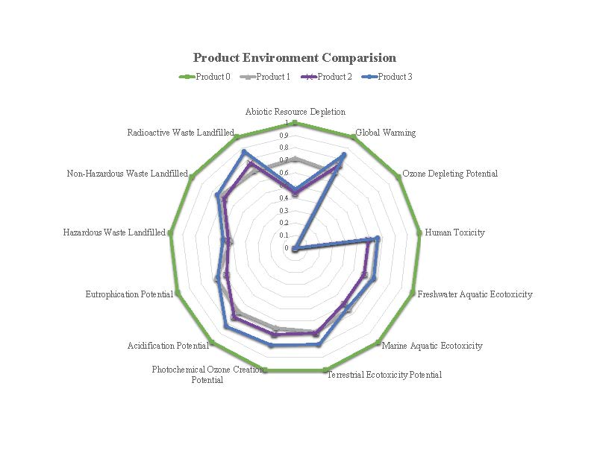

Figure 1. Example spider graph based on the LCA for different lighting options, adapted from Dillon et al. (2019)

Another way to consider the results is breaking out the information by the part of the process. Figure 2 is an example of how interesting this result might be. For energy consumption, this study reviewed many LCAs and tracked energy use by process. While transportation of the product and manufacturing are important, the energy of the lighting product during use is dramatically higher than any other phase of the product life cycle. This is an important insight about lighting that led subsequent research teams to focus on environmental impacts rather than energy since the LED lighting options were so dramatically improved for energy and cost already.



Figure 2. LCA summary for lamp types based on different processes steps (Navigant Consulting 2012)

As part of the uncertainty analysis it is often helpful to consider specific process steps as well.

Cross-checking key processes for existing studies led to the results shown in Table 2 for the transportation process of the lights. This table outlines how two different studies calculated the same transportation process for the same impact categories. In this case, the last two columns can be compared to see where higher uncertainty might occur.

Table . Example of one aspect of the uncertainty analysis for the lighting LCA; in this case, the authors compared prior work with that of an update inventory database (Dillon et al. 2019)

| **Impact Category** | **Units** | **Scholand and Dillon (2012)** | **Ecoinvent (Version 3.0)** |
| --- | --- | --- | --- |
| Acidification potential | kg SO2-Eq | 7.08E-04 | 7.37E-04 |
| Climate change | kg CO2-Eq | 5.20E-02 | 6.73E-02 |
| Eutrophication potential | kg PO4-Eq | 1.00E-04 | 1.01E-04 |
| Freshwater aquatic ecotoxicity | kg 1,4-DCB-Eq | 3.10E-04 | 7.68E-03 |
| Human toxicity | kg 1,4-DCB-Eq | 1.80E-02 | 2.76E-02 |
| Marine aquatic ecotoxicity | kg 1,4-DCB-Eq | 1.96E-02 | 2.30E+01 |
| Photochemical oxidation | kg formed ozone | 7.80E-06 | 2.55E-05 |
| Depletion of abiotic resources | Kg antimony-Eq | 3.60E-04 | 1.17E-07 |
| Stratospheric ozone depletion | kg CFL-11-Eq | 6.40E-09 | 1.18E-08 |
| Terrestrial ecotoxicity | kg 1,4-DCB-Eq | 9.30E-06 | 1.05E-04 |
| Land filling bulk waste | kg waste | 3.50E-03 | 2.87E-02 |
| Land filling hazardous waste | kg waste | 7.00E-07 | 5.74E-07 |
| Land filling radioactive waste | kg waste | 8.00E-07 | 6.73E-06 |

## Learning Objective 3.2

Sketch the system boundary and flows for a life-cycle assessment.

### Lecture Notes

The system boundaries establish the inputs and outputs included in the LCA. This is important, since it limits the inputs and outputs for the next step in the LCA. For our example, we wanted to understand the environmental impacts of lighting options, so we included raw material inputs, manufacturing, transportation of the product, use and operation of the light, and the end of life. The system diagram provides additional detail in Figure 3.



Figure 3. The system diagram for the example lighting LCA (Scholand and Dillon 2012)

As we start to detail the technology [A] matrix and create the inventory for our LCA, it often helps to sketch out each element of the system. For our example LCA, we can dive into the manufacturing process in more detail. Each step of the manufacturing can be further divided into unit processes.



Figure 4. Major steps in the packaged LED manufacturing process (Scholand and Dillon 2012)

Adding detail allows us to further develop the inputs for each process. We rely on published data for each impact category, but a process like energy production is often well characterized based on cost and environmental categories. The mass per LED is the estimate, and may have higher uncertainty.

Table . Example of one aspect unit process in full detail; this is for the material and energy used in the LED packaging assembly (Scholand and Dillon 2012)

|  |  |  |  |
| --- | --- | --- | --- |
|  |  | **Amount** | |
| **Stage** | **Material used** | **Volume per LED** | **Mass per LED** |
| Material | Ceramic substrate (2-layer alumina) | 13.5 mm2/LED | 0.0135 g/LED |
| Production | Energy (kWh) | 0.03 mm2/LED | 0.03 kWh/LED |
| Material | ESD diode (Silicon) | 0.22 mm2/LED | 0.055 g/LED |
| Material | Gold | 0.004 mm3/LED | 0.00006 g/LED |
| Material | Underfill | 0.05 mm3/LED | 0.0196 g/LED |
| Material | Silicone | 8.4 mm3/LED | 0.00006 g/LED |

### References

Dillon HE, C Ross, and R Dzombak. 2019. Environmental and Energy Improvements of LED Lamps over Time: A Comparative Life Cycle Assessment. *LEUKOS The Journal of the Illuminating Engineering Society*, 1–9. <https://doi.org/10.1080/15502724.2018.1541748>

Heijungs R and S Suh. 2002. *The Computational Structure of Life Cycle Assessment*. <https://doi.org/10.1007/978-94-015-9900-9>.

International Organization for Standardization. 2006. *ISO 14040:2006 - Environmental management -- Life cycle assessment -- Principles and framework*. Pub. L. No. ISO 14040:2006. <https://www.iso.org/standard/37456.html>

Navigant Consulting. 2012. Life-Cycle Assessment of Energy and Environmental Impacts of LED Lighting Products, Part 1: Review of the Life-Cycle Energy Consumption of Incandescent, Compact Fluorescent, and LED Lamps. In *Energy*. Retrieved from <http://apps1.eere.energy.gov/buildings/publications/pdfs/ssl/2012_LED_Lifecycle_Report.pdf>.

Scholand MJ and HE Dillon. 2012. *Life-Cycle Assessment of Energy and Environmental Impacts of LED Lighting Products, Part 2: LED Manufacturing and Performance*. PNNL-21443, prepared by Pacific Northwest National Laboraotry for the U.S. Department of Energy. Retrieved from <https://www.pnnl.gov/main/publications/external/technical_reports/PNNL-21443.pdf>.