LAND IS GRADED: FINAL GRADE SLOPES AWAY FROM FOUNDATION

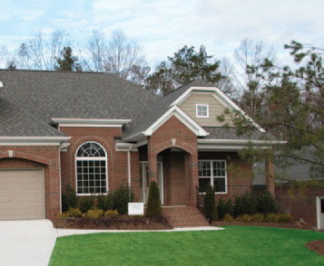 | WHAT?  Complete foundation water barrier systems include the grading step. The new home’s immediately surrounding land is graded, and the final grade slopes away from the house. This helps drain water away from the slab, footing, and below-grade walls.
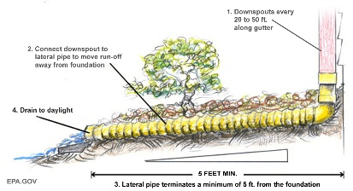 | WHY?  Grading land away from the new home’s foundation is a necessary step in fully protecting the foundation. In addition to improving building durability, grading helps prevent mold from forming (and thus, rot), and it helps safeguard indoor air quality—all of which contribute to occupant comfort, health, and safety.
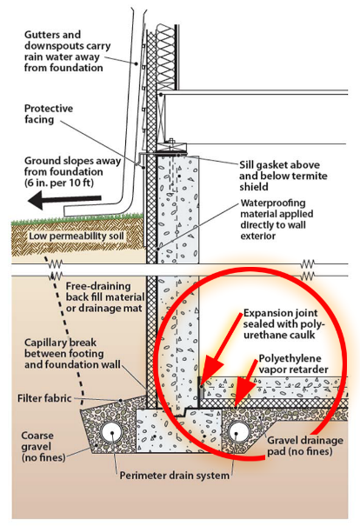 | HOW?  Make sure that water drains away from the house on all sides. Guide stormwater runoff away from the foundation by:  - Sloping the final grade away from the house (at minimum 0.5 inch per foot for 10 feet).  - Excavate  - Install foundation footings, stem wall, and slab  - Put in footing drain pipe, waterproofing, and exterior insulation  - After construction, backfill to the foundation walls, grade the slope, cap the top layer of the grade with 2 to 4 inches of silty clay, and mechanically compact (tamp) the soils to prevent settling.  - Installing either swales or drains designed to transport water away from the foundation if the space is less than 10 feet.  Applicable codes include ENERGY STAR-Certified Homes Rev. 9, DOE Zero Energy Ready Home Rev. 7, EPA Indoor airPLUS Rev. 4, EPA WaterSense® New Home Specification, and 2021 International Residential Code (IRC).

