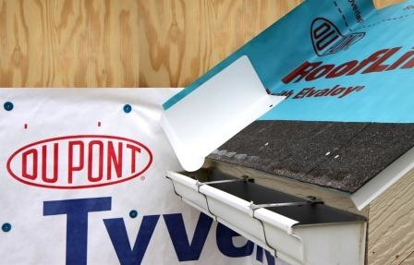 | WHAT?  Kick-out flashing, or diverters, should be installed at the eaves of all roof-wall intersections. This flashing diverts rainwater runoff into gutters and protects walls from water intrusion. Diverters consist of prefabricated seamless, molded plastic pieces or metal with welded seams.
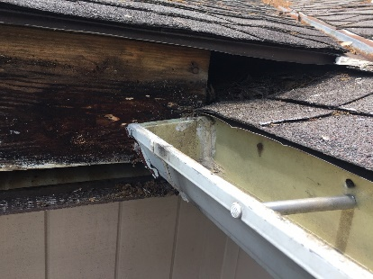 | WHY?  In big storm events, rainwater often can overflow the gutter and stream down the walls. Diverters can help direct water into the gutters, but they must be right sized and integrated with the water-resistant barrier, or housewrap. Otherwise, they can allow water inside wall cavities.
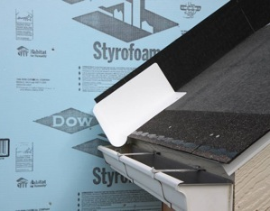 | HOW?  Kick-out flashing directs rainwater into rain gutters where it can be carried away from the structure. Kick-out flashing, also called diverters, can be fabricated on site using sheet metal, but these can be undersized and may have unsealed seams that allow leakage. A better option is prefabricated kick-out flashings that are available as seamless, molded plastic pieces or metal with welded seams.
ROOFING: KICK-OUT FLASHING (DIVERTERS) AT ROOF-WALL INTERSECTIONS

