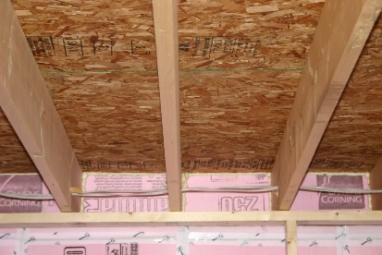 | WHAT?  Insulating and air-sealing rim joists is a critical step when insulating a floor over an unconditioned basement or crawlspace. Rim joists are usually insulated and air-sealed with either rigid foam or spray foam. The practice helps create a continuous air barrier.
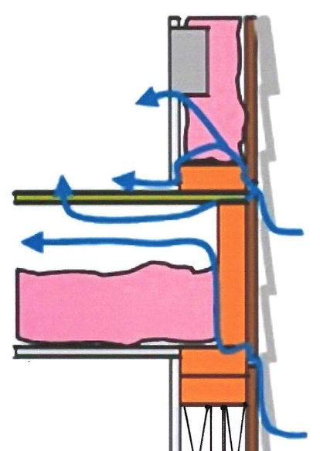 | WHY?  Floors can account for one-fourth to one-third of the building enclosure’s surface area. Air can infiltrate through the framing, including the band joist and rim joist.  Defects in the air barrier and insulation system can cause heat loss through floors over unconditioned basements or vented crawlspaces. This results in higher energy costs and uncomfortably cold floors. Air-sealing and insulating the band and rim joists helps create a complete and continuous air barrier.
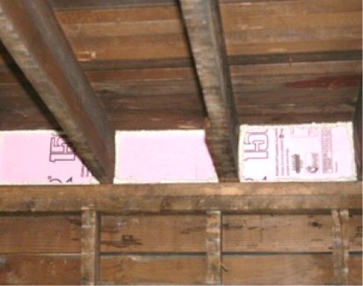 | HOW?  Rim joists can be sealed with rigid foam that is cut to fit the space. Caulk or spray foam at the edges seals the rigid foam in place. Rim joists can also be air-sealed and insulated in one step using spray foam insulation. To qualify as an air barrier, open-cell or closed-cell foam must have a finished thickness greater than or equal to 5.5 inches or 1.5 inches, respectively.
INSULATION PROCESS/REQUIREMENTS: INSULATING AND SEALING RIM JOISTS

