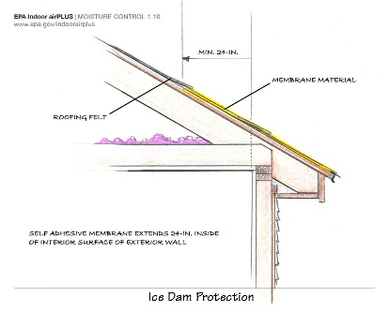 | WHAT?  In cold climates (Climate Zones 5 and higher) a protective membrane should be installed along the roof eaves to help protect the edge of the roof from ice dam formation. The membrane must be installed from the edge of the roof deck over the eave and extend over the attic space at least two feet.
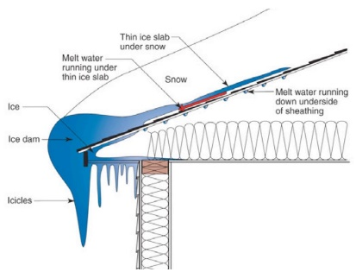 | WHY?  Cold climates present a special challenge to a home's roof. During the cold months, freeze-thaw cycles can lead to the formation of ice dams. In severe cases, ice dams have caused roof collapses. Just as damaging, the accumulating water can back up between the shingles then saturate and penetrate the roof underlayment and begin leaking into the attic. Sealing the eaves can protect them from water intrusion.
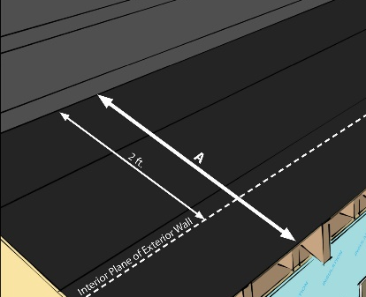 | HOW?  The self-sealing membrane should extend at least two feet in from the interior plane of the wall. The membrane should be installed starting at the eave edge first. Extending the self-sealing membrane over the metal drip edge ensures water will not find access at the very edge of the eave.
ROOFING: INSTALLING SELF-SEALING MEMBRANE AT EAVES

