WATER-MANAGED WALLS:WRB

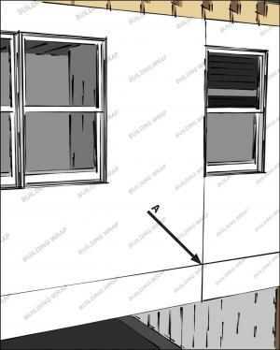 | WHAT?  Most exterior wall cladding systems leak at some point because of wind pressure and capillary action, which can drive rainwater through the many cracks, joints, and small gaps. With typical residential siding systems, it is almost impossible to seal all these holes.
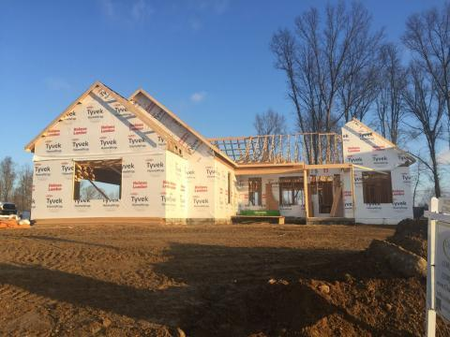 | WHY?  Wall moisture control systems help divert and drain water away from above-grade walls and help minimize the risk of water damage in the home.
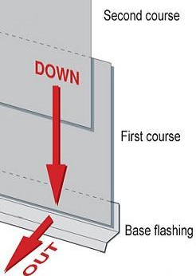 | HOW?  With a drainage approach to protect a home’s exterior from rainwater, any water that leaks through the cladding will run into a water-resistant surface (that is, housewrap or rigid foam) and safely drain down and out of the wall.  Housewrap should be securely taped or sealed at all seams and lapped over any exterior wall flashings installed around window and door openings or where roofs intersect walls. Any holes through the wall (for example, for water spigots, exhaust vent outlets, HVAC line sets, or wiring for outdoor light fixtures and receptacles) should also be thoroughly sealed or gasketed.

