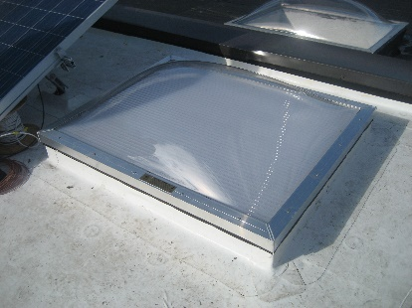 | WHAT?  Inspecting skylights for water damage and infiltration can help determine whether the unit should be replaced or repaired. These inspections should be done any time renovations that involve the roof are conducted. Installers should take the opportunity to inspect the skylights for signs of leakage, and to determine if proper flashing and other water management details are in place to prevent future water leaks.
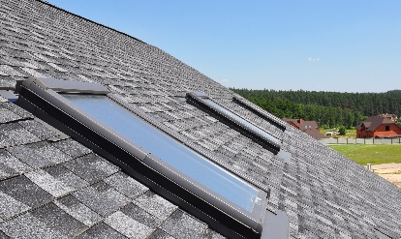 | WHY?  Skylights are among the most common sources of water infiltration issues in a home. Controlling rainwater is the single most important factor in the design and construction of durable roof assemblies. Checking for leaks and water damage is an essential step in determining whether to replace or repair a skylight.
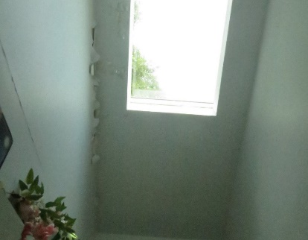 | HOW?  There are several steps to assessing skylights for water damage and leaks:  Inspect from the interior of the home for signs of water infiltration around a skylight including peeling interior paint and water stains on framing.  Inspect the integrity of the roof covering (roof shingles and underlayment) for water damage.  Inspect the structural integrity of the roof sheathing and framing.  Inspect the skylight for signs of water leakage through the unit itself or between the frame and sash.  Test for water leakage by spraying the skylight unit and surrounding roof covering with a garden hose and looking for active water leaks.
ROOFING: INSPECTING SKYLIGHTS FOR WATER DAMAGE AND INFILTRATION

