Pollutants That Can Impact Indoor Air Quality

Common sources of indoor air pollution are moisture-generated problems like mold, dust mites, and bacteria, as well as pollutants like carbon monoxide, volatile organic compounds, radon, and particulates.

Mold needs moisture and a food source to grow. If indoor moisture levels are high enough, there are many different areas in a building that will supply the food needed for mold growth. For instance, mold loves to grow on wood surfaces, as well as on resilient ceiling tiles and the paper facings of insulation and drywall. But mold can also grow on dirt and pollen, and if these lodge themselves inside the building’s ductwork, mold that grows there will be distributed throughout the building.

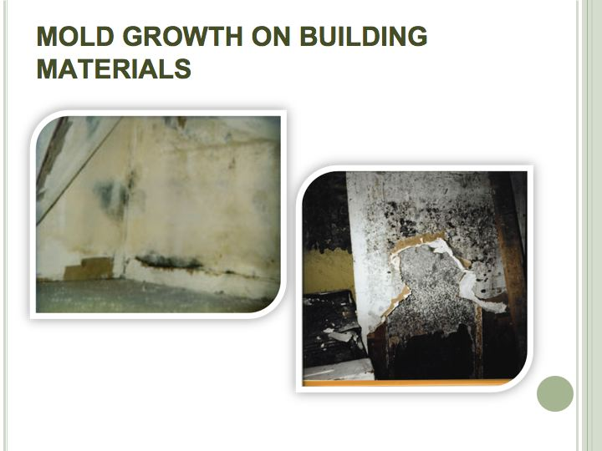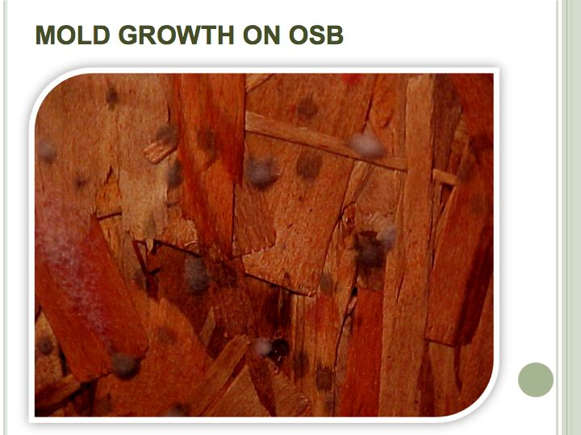

Mold can seriously impact indoor air quality. Elevated moisture levels can cause mold to grow on surfaces such as drywall or oriented strand board.

Dust mites and bacteria can also multiply when moisture levels are elevated. Dust mites tend to grow in soft surfaces like bedding and carpet, and the higher the humidity, the more comfortable these organisms are.

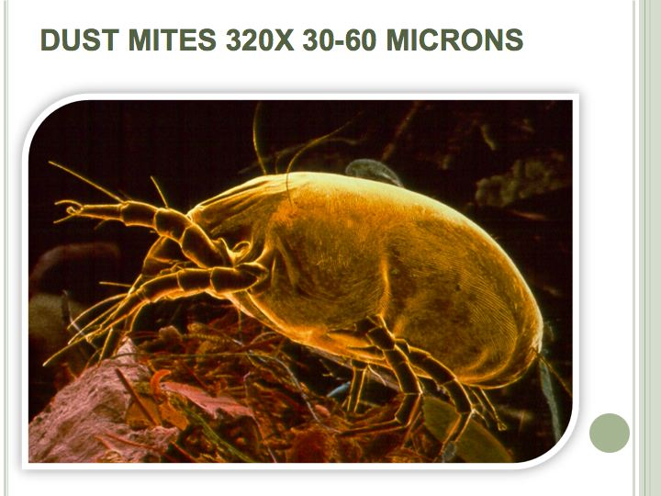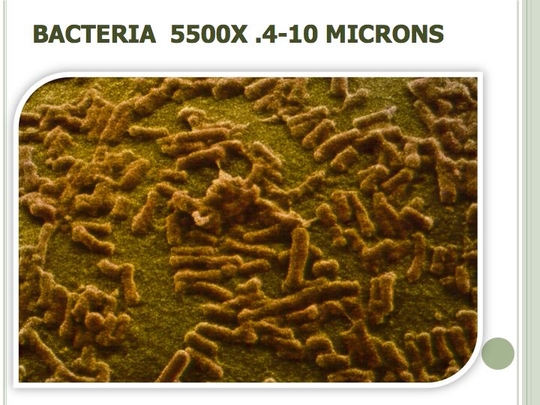

Allergens like dust mites and bacteria are also more likely to multiply when humidity levels are high.

Carbon monoxide, which is produced by the incomplete combustion of fuel, tends to be concentrated in buildingss that have un-vented cooking appliances, a wood burning fireplace or a fireplace connected to a blocked chimney. Carbon monoxide can also come from the back drafting of appliances and fireplaces, which can of course be caused by energy efficiency practices that affect natural ventilation rate and internal air pressures.

