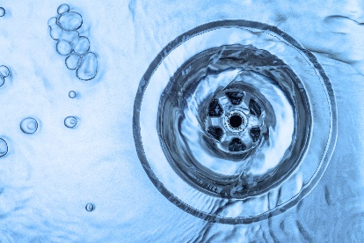 | WHAT?  Some fixtures run cold for a long time before the hot water finally arrives. For example, every 60 seconds of shower run-time amounts to about three gallons of water that is wasted. This is happening multiple times every day in many places, so it adds up.
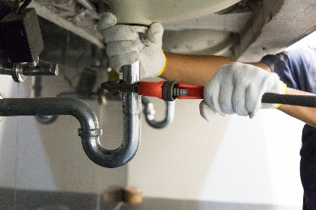 | WHY?  Efficient hot water distribution addresses the issue of wasted cold water. Homes designed now should have plumbing layouts that deliver hot water much more efficiently. DOE’s Zero Energy Ready Home program requires that no more than 0.6 gallons of hot water be discharged from the fixture farthest from the water heater before hot water arrives at the tap.
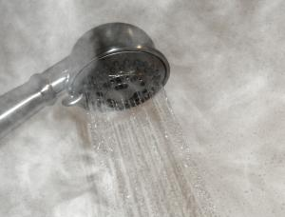 | HOW?  On-demand hot water systems distribute water more efficiently and provide hot water with no wait time. Each year in one home, that translates to thousands of gallons of water being saved along with money saved on water bills.
PLUMBING DISTRIBUTION SYSTEM: EFFICIENT HOT WATER DISTRIBUTION

