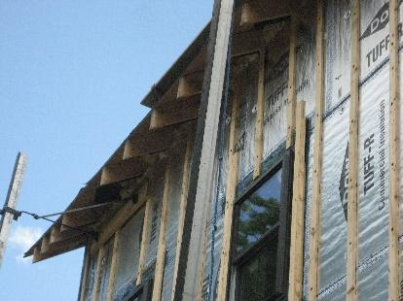 | WHAT?  Insulation is typically rated by its R-value, or resistance to heat transfer. Building codes set minimum requirements for insulation R-values in ceilings, walls, and floors. Because high-R insulation meets or exceeds the requirements of these codes, including the 2015 International Energy Conservation Code (IECC), it is used in high-performance and zero-energy ready homes.  Ultra-efficient insulation is 25% more efficient than requirements of the 2015 IECC.
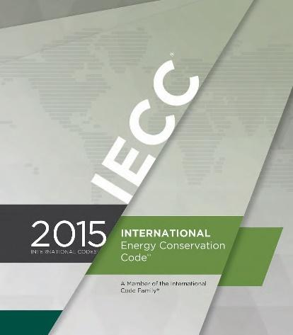 | WHY?  Initial construction offers the best opportunity for bolstering the thermal envelope of a home. High-efficiency insulation provides extra added thermal protection that meets or exceeds the requirements of the IECC, which is the U.S. model energy code.  When installed properly, high-R insulation creates spaces that require very little heating and cooling. High-R insulation also contributes to spaces that are evenly comfortable and quiet.
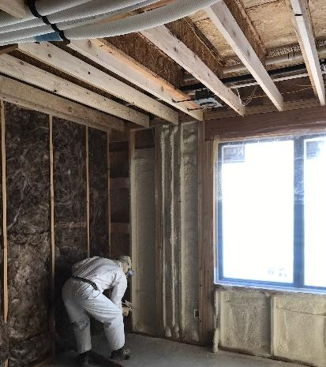 | HOW?  There are two levels of high-R insulation: high-efficiency insulation, which meets the levels required by the 2015 IECC, and ultra-efficient insulation, which is 25% more efficient than this code.  To be most effective, high-efficiency and ultra-efficient insulation must be installed correctly. Professional installation ensures there are no gaps, voids, compression, or misalignment with air barriers; complete air barriers; and minimal thermal bridging.

