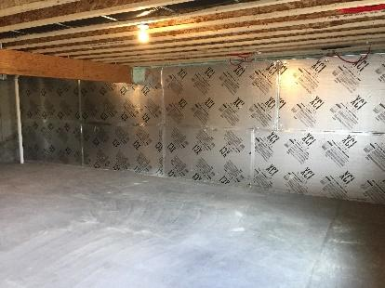 | WHAT?  To create a complete thermal envelope, basements, concrete slabs, and below-grade walls should be insulated. The building code specifies levels of insulation for these areas based on the climate zone. High-R foundations meet or exceed the levels of the International Energy Code Council, or IECC, and can help create high-performance and zero-energy-ready homes.  Ultra-efficient insulation is 25% more efficient than requirements of the 2015 IECC.
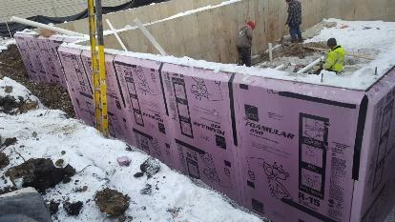 | WHY?  Lack of insulation on foundations, crawlspaces, and under slabs can account for a significant proportion of a home’s energy loss. A bare concrete slab acts like a thermal bridge between a building’s heated interior and the earth, which is significantly colder.
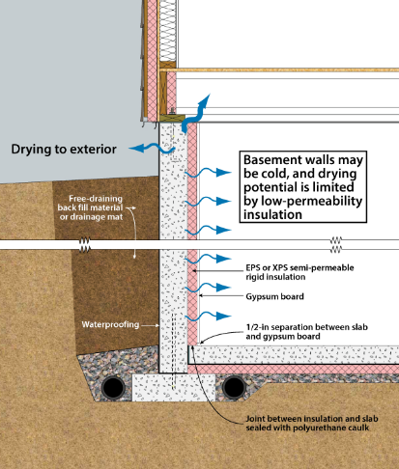 | HOW?  There are two types of high-R foundations. High-efficiency insulation meets the requirements of the 2015 International Energy Conservation Code. Ultra-efficient insulation is 25% more efficient than this national code. These high levels of insulation are often achieved by installing rigid foam or rigid mineral fiber insulation panels around the perimeter of a concrete slab, and sometimes underneath. In some cases, rigid foam and/or spray foam insulation can be installed on the inside of basement walls, but careful attention must be paid to moisture management.  To be most effective, high-efficiency and ultra-efficient insulation must be installed correctly with no gaps, voids, compression, or misalignment with air barriers; complete air barriers; and minimal thermal bridging.
INSULATION CODE: HIGH-R FOUNDATIONS

