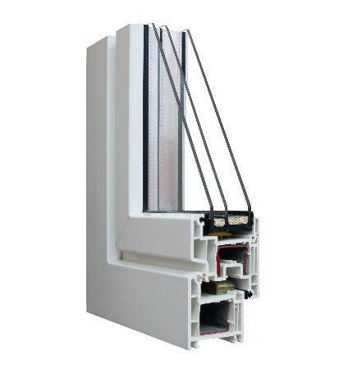 | WHAT?  High-performance window systems help make a home more comfortable while reducing energy usage. They use a combination of insulating frames and other features to reduce heat loss. On average, these systems can save homeowners 7% to 15% on utility bills.  High-performance windows systems can reduce utility bills by 7% to 15%.
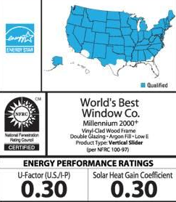 | WHY?  When it comes to energy loss, windows and doors are weak points in the building envelope. But homes with high-performance window systems are more comfortable and consume less energy than homes with traditional windows. High-efficiency ENERGY STAR-rated windows perform at least 15% better than standard windows and have an insulating value of R-3 or higher. Ultra-efficient windows perform at least 50% better than standard windows and have an insulating value of R-5 or higher.
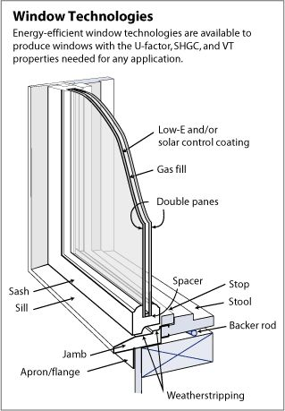 | HOW?  High-performance windows consist of two or three glass panes separated by insulating spacers and are installed in insulated frames made of nonconductive wood, fiberglass, or vinyl. The space between the glass layers is filled with a nontoxic gas like argon or krypton that insulates better than air. The glass panes are coated with a low-emissivity coating that reflects sunlight and protects curtains, furniture, and hardwood floors from fading over time.
HIGH-PERFORMANCE WINDOW SYSTEMS

