HIGH-PERFORMANCE WINDOW SYSTEMS: GLASS

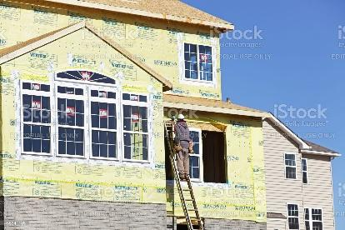 | WHAT?  The glass in high-performance window systems is designed to reduce heat transfer, reducing energy usage while helping make a home more comfortable. Features that help reduce heat transfer include two or three panes of insulated glass and low-emissivity coatings.  Low-e storm windows can save between 10%–30% in heating and cooling costs.
WHY?
Glass transfers heat by absorbing heat from the sun and transferring it to the other side of the pane and into the room. This can overheat rooms and make them less comfortable, requiring more energy to cool the room. Shades can help, but they also block natural daylight, which may not be desirable. Windows with high-performance glass are more energy efficient and help keep rooms more comfortable than conventional windows.
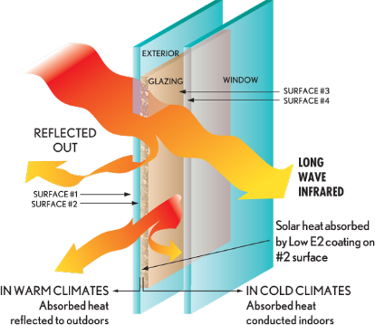 | HOW?  High-performance windows consist of two or three glass panes separated by insulating spacers and installed in insulated frames made of nonconductive wood, fiberglass, or vinyl. The space between the glass layers is filled with a nontoxic gas like argon or krypton that insulates better than air. The glass panes are coated with a low-emissivity coating that blocks radiant energy but allows visible light to come through. Low-e coatings prevent overheating and protect curtains, furniture, and hardwood floors from fading over time.

