Types of Insulation
R-value varies by thickness and material.

R-Values for standard insulating materials per 1-inch thickness
Fiberglass batt (1.0 lb./ft.) | 3.16
Fiberglass high-density batt (3.0 lb./ft.) | 4.3
Fiberglass loose fill | 2.2
Cellulose | 3.2 to 3.7
Extruded polystyrene foamboard (closed cell ) | 4.5 to 5.2
Molded/expanded polystyrene foamboard | 3.85 - 4.35
Spray urethane (closed cell) | 6.0 – 6.5
Spray polyicynene | 3.6

R-Values for standard building materials per 1-inch thickness
Concrete block | 0.139
Brick | 0.2
Poured concrete | 0.08
Softwood lumber | 1.25
Plywood | 1.25
R-Values for standard building materials per total thickness
Drywall (1/2 inch) | 0.45
Carpet (fibrous backing) | 2.08
Rubber carpet pad | 1.23
Single-pane glass | .91

Fiberglass is made with long filaments of glass that are felted and cut into blankets or batts to fit within a stud cavity. Batts can have an asphalt-laminated Kraft paper, or a foil vapor barrier on one side with a flange for attaching to studs. The batts also may be unfaced; these are designed for a friction fit. Higher density batts are now available to boost the R-value of a standard 2x4 wall from R-11 to R-13.

Fiberglass itself is not combustible. Fiberglass insulation is cost-effective, easy to install during construction, resistant to water damage, and does not settle. Some newer versions are encapsulated in perforated plastic to make installation easier. The disadvantage of fiberglass is that it has to be installed very well in order to work right.

Fiberglass insulation does not block airflow. A Kraft-paper facing helps, but Kraft paper cannot completely block air infiltration. In very cold climates or where moisture transfer from diffusion is an issue because of high indoor humidity levels, Kraft-faced insulation is a poor choice.
However, Kraft-faced insulation does make sense in mixed and warm climates where codes may still require a vapor barrier on the inside but where poly might create a summer cold-side vapor barrier (which would trap moisture in the wall cavity). A Kraft vapor barrier is "smart": As it becomes more saturated, its permeability increases, allowing the wall cavity to dry to the inside.

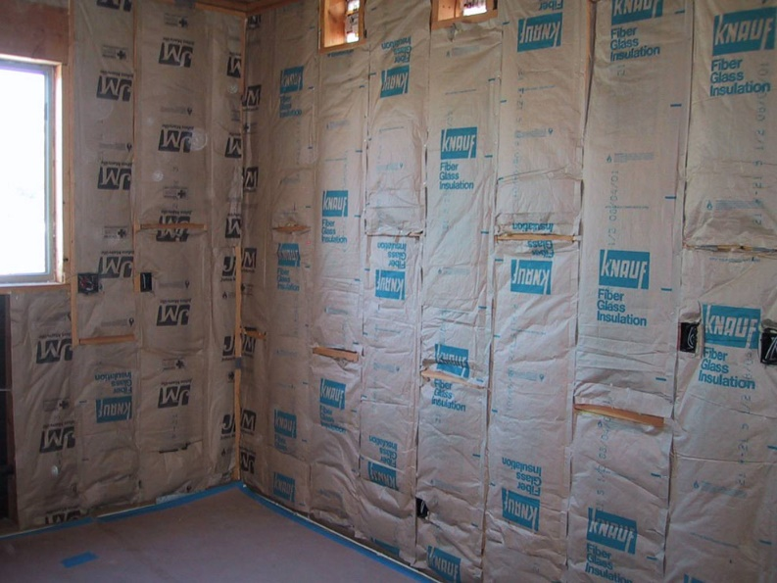

A poly or foil vapor retarder behaves very differently from Kraft paper in a mixed climate. Since the perm rating of foil or poly stays constant, it does not pass any moisture and therefore traps moisture in the wall cavity. This interaction between insulation and vapor retarders will be explored further in Lesson 7.
Kraft-faced insulation

Cellulose is an organic material made from virgin and recycled paper products. Additives are added to reduce flammability. The cellulose is typically blown into stud cavities with a high-powered blower, which does a good job of filling the cavity and usually prevents any uninsulated areas. Cellulose fits well into irregular spaces.

Other advantages of cellulose include the fact that cellulose is a recycled product and is environmentally friendly. Also, when it is blown into the walls at the proper density, it does help to seal air leaks.

However, there are some disadvantages. Blown at the wrong density, cellulose settles and loses performance. If it gets wet, it creates a mess and has a slow drying time because the material is hydroscopic (meaning it absorbs moisture from the atmosphere). Wet-spray cellulose must be installed at the correct moisture content; if applied too wet, it can slow construction schedules until it dries.

Extruded polystyrene (blue or pink foam boards). Extrusion of a polymer results in a closed cell foamboard with air pockets containing air and possibly fluorocarbons (refrigerant gas). The closed-cell structure means that the gas bubbles that form when the material is made remain permanently locked in the cured board. Because there are no interconnections between individual bubbles, the foam absorbs little water and also resists the passage of water vapor.

The R-value of polystyrene is relatively high at R-5 per inch. This type of foamboard resists moisture damage, is easy to work with in 2x8 or 4x8 sheets, and provides some structural strength. Extruded polystyrene is flammable and must be covered with a nonflammable product. Also, it is adversely affected by UV light, and degradation occurs at temperatures above 165°F. It does expand and contract, potentially making for poor tape adhesion.

Expanded, or molded, polystyrene (white board). “Beadboard” has a lower R-value than extruded polystyrene because it is less dense; it has fewer air pockets per given thickness. The air pockets or cells do not contain fluorocarbons. This insulation is easy to work with, has some structural strength, is resistant to water damage, and has a relatively high R-value.

However, as with the extruded poly, molded poly must not face prolonged UV exposure. In addition, it is flammable and degrades at temperatures over 165°F.

Spray foam. Dense spray systems have a closed-cell structure — the gas bubbles that form during the application process remain permanently locked into the cured foam. On the other hand, lower-density foam has an open-cell structure: a structure more like a sponge. The cured material consists of a series of tiny interconnected passageways. These open cells are too small to permit convective airflow, but they are more permeable to water vapor than closed-cell foams.

Spray foams work exceptionally well when used in conjunction with more economical systems to seal small or unusual spaces that are otherwise difficult to seal.

Density and R-value varies widely. Commercial flat roofs, for example, are often insulated with a high-density material that weighs about 3 pounds per cubic foot, which makes it hard and strong enough to walk on without damage. But most residential foam insulation weighs between .5 and 2.0 pounds per cubic foot. A 1/2-pound foam, such as Icynene for example, has an R-value of about 3.5 per inch — roughly the same as fiberglass batts or loose-fill cellulose. A denser, 1.8-pound foam, on the other hand, has an R-value approaching 7.

Foamed-in-place insulation no longer contains urea formaldehyde. Products currently available are made from petroleum-based isocyanurate and urethane resins, which are often made from sugar cane or soybeans. Potentially toxic vapors may be present while the foam is actually being applied, but the cured material is nontoxic and will not offgas harmful chemicals.

Reflective surface insulation. Unlike other insulation, reflective insulation works by reducing the radiant heat transfer. This is used after conductive and convective heat losses have been addressed. Foil is an excellent vapor barrier, but it must be used in addition to other insulation. Radiant barriers must be installed with an air space or they become conductors of heat. Dust and moisture can dull the reflective surfaces and reduce the effectiveness.

The Law of Diminishing Returns
When evaluating any insulation system, it's important to pay attention to the payback. Every time you double your insulation, your heat loss is cut in half — this is subject to diminishing returns.

Savings related to heating or cooling are inversely proportional to the R- value of the building envelope. If the R- value is doubled, the heating portion of the energy bill will be cut in half. However, there is a point of diminishing return. Increasing your R-value beyond the level possible with 2x6 studs will not pay for itself in the long run. For example, if you have R-10 in your stud cavity and have a $2,000 heating bill, and then you increase your insulation to an R- value of 20, your energy bill will be cut to $1,000. However, increasing your R-value from 20 to 40 will save you only $500, but will cost thousands of dollars in construction and materials.

